
INDUSTRY REPORT
Real Estate & Rental & Leasing in the US
Feb 2026

About

IBISWorld
IBISWorld specializes in industry research with coverage on thousands of global industries. Our comprehensive data and in-depth analysis help businesses of all types gain quick and actionable insights on industries around the world. Busy professionals can spend less time researching and preparing for meetings, and more time focused on making strategic business decisions.

Table Of Contents | Standard

1. About 4
Codes 4
Definition 4
Related Terms 4
What's Included 4
Companies 4
Related Industries 4
Additional Resources 5
2. At a Glance 6
Key Takeaways 6
Products and Services 7
Major Players 8
Key External Drivers 9
Industry Structure 9
SWOT 10
Executive Summary 10
3. Performance 11
Highlights 11
Key Takeaways 11
Performance Snapshot 12
Outlook 20
Life Cycle 22
4. Products and Markets 23
Key Takeaways 23
Products and Services 24
Major Markets 28
International Trade 30
5. Geographic Breakdown 31
Key Takeaways 31
Business Locations 32
6. Competitive Forces 37
Key Takeaways 37
Concentration 37
Barriers to Entry 39
Substitutes 40
Buyer & Supplier Power 41
7. Companies 43
Key Takeaways 43
Market Share 44
Companies 45
8. External Environment 48
Key Takeaways 48
External Drivers 48
Regulation & Policy 51
Assistance 53
9. Financial Benchmarks 54
Key Takeaways 54
Cost Structure 54
Key Ratios 57
10. Key Statistics 59
Industry Data 59

1. About
https://my.ibisworld.com/us/en/industry/53/about

Codes
NAICS 2017 - USA | 53
NAICS 2022 - USA | 53

Definition
This sector is primarily concerned with operators involved in the management, sale, purchase and rent of real estate. This sector also includes the renting and leasing of tangible goods, such as equipment, and intangible goods, such as patents. It is important to note that operators primarily engaged in commercial mortgages, which are treated as financial instruments, are not included in this industry.

Related Terms

REAL ESTATE INVESTMENT TRUST (REIT)
A company that owns and, in most cases, operates income-producing real estate.

OCCUPIER OUTSOURCING
Relocation services.

RENTAL VACANCY RATE
The measure of unoccupied rental units on the market.

What's Included
- Real estate
- Renting and leasing
- Lessors of nonfinancial intangible assets

Companies
- Realogy Holdings Corp.

Related Industries

Industries in the Same Sector
- Competitors:
  - Construction, Mining & Forestry Equipment Wholesaling in the US
  - Community Housing & Homeless Shelters in the US
- Complementors:
  - No data available

International Industries
- Global Commercial Real Estate

Additional Resources
- Federal Home Loan Mortgage Corporation
- Department of Housing and Urban Development
- National Association of Realtors

2. At a Glance
https://my.ibisworld.com/us/en/industry/53/at-a-glance
Revenue  $1.5tr  ’21-’26 ↑ 1.3 %  ’26-’31 ↑ 1.6 % | Employees  6m  ’21-’26 ↑ 2.1 %  ’26-’31 ↑ 1.6 % | Businesses  4m  ’21-’26 ↑ 1.5 %  ’26-’31 ↑ 1.6 %
Profit  $730.7bn  ’21-’26 ↑ 1.8 % | Profit Margin  49.1%  ’21-’26 ↑ 1.3 pp | Wages  $249.7bn  ’21-’26 ↑ 0.7 %  ’26-’31 ↑ 1.6 %

Key Takeaways

Performance
- Affordability pressures are reshaping housing demand. Elevated prices, higher mortgage rates and construction costs are suppressing home sales while pushing more households into single-family rentals, build-to-rent communities and multifamily options, where occupancy and rents remain relatively resilient.
- Industrial and equipment rentals are benefiting from e-commerce growth and megaproject pipelines. Rising online sales and large semiconductor, EV and infrastructure projects are driving sustained demand for logistics space, truck rentals and specialized heavy equipment on long-term contracts.

Products and Markets
- The sector’s outlook is resilient but structurally bifurcated between ownership and rental. Persistently tight for-sale supply, higher-for-longer rates and rising equipment ownership costs will favor rental models across housing, industrial assets and machinery, rewarding rental providers that prioritize efficiency, flexibility and value-oriented offerings.
- Consumers are embracing rentals and leasing as a way to access goods without heavy debt. From autos to electronics and household items, short-term or no-credit-needed options appeal to households facing higher living costs and tighter credit conditions.

Products and Services
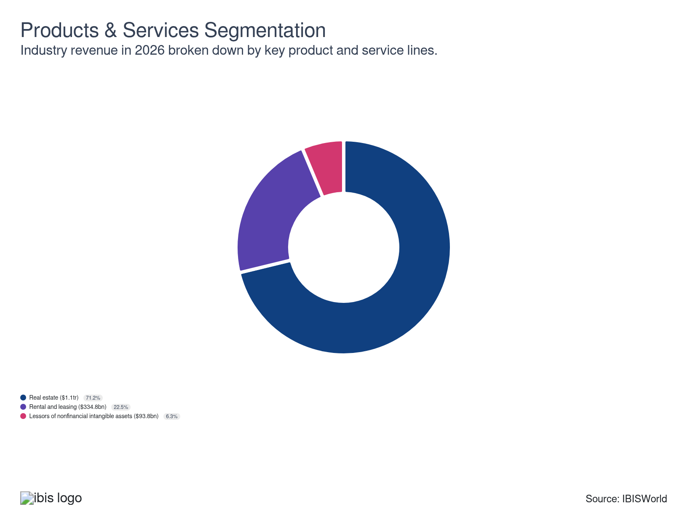

Major Players


Key External Drivers
Key External Drivers | Impact
Rental vacancy rates | Negative
Value of residential construction | Positive
Per capita disposable income | Positive
Homeownership rate | Negative
Yield on 10-year Treasury note | Positive

Industry Structure
Characteristic | Level | Trend
Concentration | Low
Barriers To Entry | Low | Steady
Regulation and Policy | Moderate | Steady
Life Cycle | Mature
Revenue Volatility | Low
Assistance | Low | Steady
Competition | Moderate | Increasing
Innovation | Moderate

SWOT
Strengths  High Profit vs. Sector Average | Weaknesses  High Customer Class Concentration  High Product/Service Concentration  Low Revenue per Employee  High Capital Requirements | Opportunities  High Revenue Growth (2021-2026)  High Revenue Growth (2026-2031)  High Performance Drivers  Per capita disposable income | Threats  Low Revenue Growth (2005-2026)  Low Outlier Growth  Rental vacancy rates

Executive Summary

For Rent: Renters, not buyers bolster sector growth
The Real Estate and Rental and Leasing sector continues to face affordability challenges that are reshaping housing demand. Elevated home prices, higher mortgage rates, costlier insurance and construction inflation have locked many households out of homeownership, keeping existing home sales stagnant at 4.06 million in 2025. Despite demographic tailwinds, transaction volumes have cooled, prompting price adjustments in higher-end segments. As ownership becomes less accessible, rental markets, especially single-family rentals, build-to-rent communities and multifamily housing, remain resilient. High occupancy and steady rents have drawn investment toward workforce and suburban housing, while luxury developments face tighter scrutiny. Property technology firms and brokerages are expanding affordability tools, such as rate buydowns, rent-to-own options and shared-equity models, to reach sidelined buyers. Nonetheless, revenue has increased at a CAGR of 1.3% to $1.5 trillion through the end of 2026, including an anticipated 0.7% gain in 2026 alone.
Residential real estate revenues have stayed firm, driven by sustained price appreciation despite lower transaction volumes. Affordability constraints pushed the share of first-time buyers to a record low of 21.0%, with their median age rising to 40. Meanwhile, robust e-commerce activity, now accounting for 16.4% of retail sales, has strengthened demand for industrial space and freight services, benefiting truck rental and logistics providers. Large-scale construction efforts, including semiconductor, EV manufacturing and infrastructure megaprojects, have further supported the equipment rental market, generating long-duration contracts and encouraging providers to scale specialized fleets and digital management systems.
The sector will remain divided between constrained ownership markets and expanding rental segments. Housing supply will improve slowly amid high financing and material costs, keeping prices and mortgage rates elevated. Rental housing, particularly mid-market and suburban units, will continue to absorb displaced buyers, sustaining occupancy and investment flows. Equipment rental will gain as firms seek flexible access to increasingly expensive and complex machinery, while rental and leasing providers will strengthen omnichannel strategies to meet digital-first consumer expectations. Overall, the US real estate and rental and leasing industry will remain resilient but will focus on affordability, operational efficiency and adaptive business models to navigate ongoing economic and structural headwinds. Overall, industry revenue will expand at a 1.6% CAGR over the next five years, reaching $1.6 trillion in 2031.

3. Performance
https://my.ibisworld.com/us/en/industry/53/performance

Highlights
Revenue  $1.5tr  2021-26 CAGR ↑ 1.3 %  2026-31 CAGR ↑ 1.6 % | Employees  6m  2021-26 CAGR ↑ 2.1 %  2026-31 CAGR ↑ 1.6 % | Businesses  4m  2021-26 CAGR ↑ 1.5 %  2026-31 CAGR ↑ 1.6 %
Profit  $730.7bn  2021-26 CAGR ↑ 1.8 % | Profit Margin  49.1%  2021-26 CAGR ↑ 1.3 pp

Key Takeaways
- Affordability pressures are reshaping housing demand. Elevated prices, higher mortgage rates and construction costs are suppressing home sales while pushing more households into single-family rentals, build-to-rent communities and multifamily options, where occupancy and rents remain relatively resilient.
- Industrial and equipment rentals are benefiting from e-commerce growth and megaproject pipelines. Rising online sales and large semiconductor, EV and infrastructure projects are driving sustained demand for logistics space, truck rentals and specialized heavy equipment on long-term contracts.

Performance Snapshot
Revenue: | ↑ 2021-26 Revenue CAGR +1.3%
Revenue  $1.5tr  ’21-’26 ↑ 1.3 %  ’26-’31 ↑ 1.6 % | 2026 Revenue Growth  ↑ 0.7 % | Revenue Volatility  Low
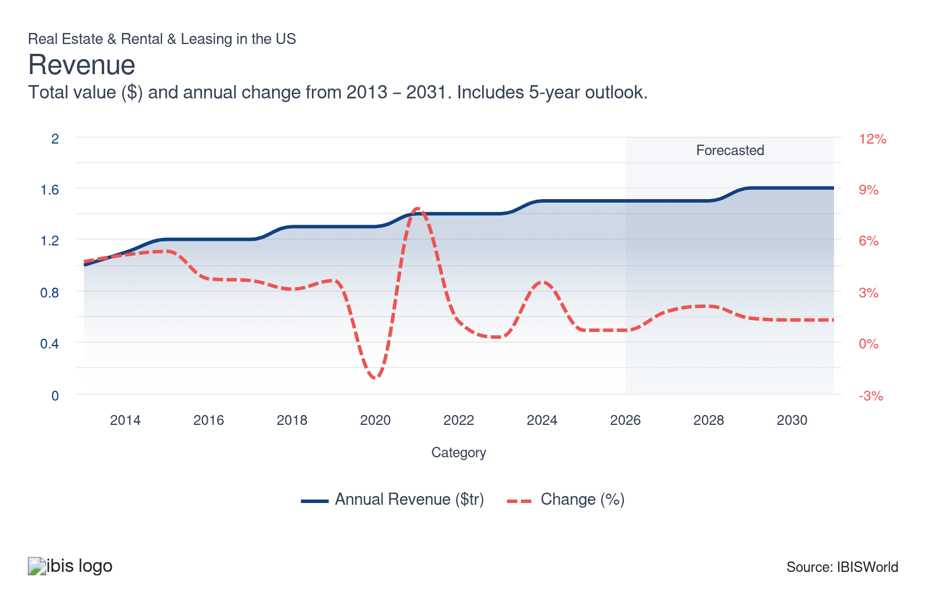
Employees: | ↑ 2021-26 Employees CAGR +2.1%
Employees  6m  ’21-’26 ↑ 2.1 %  ’26-’31 ↑ 1.6 % | Employees per Business  2  ’21-’26 ↑ 0.6 %  ’26-’31 ↑ 0.0 % | Revenue per Employee  $255k  ’21-’26 ↓ 0.8 %  ’26-’31 ↓ 0.0 %
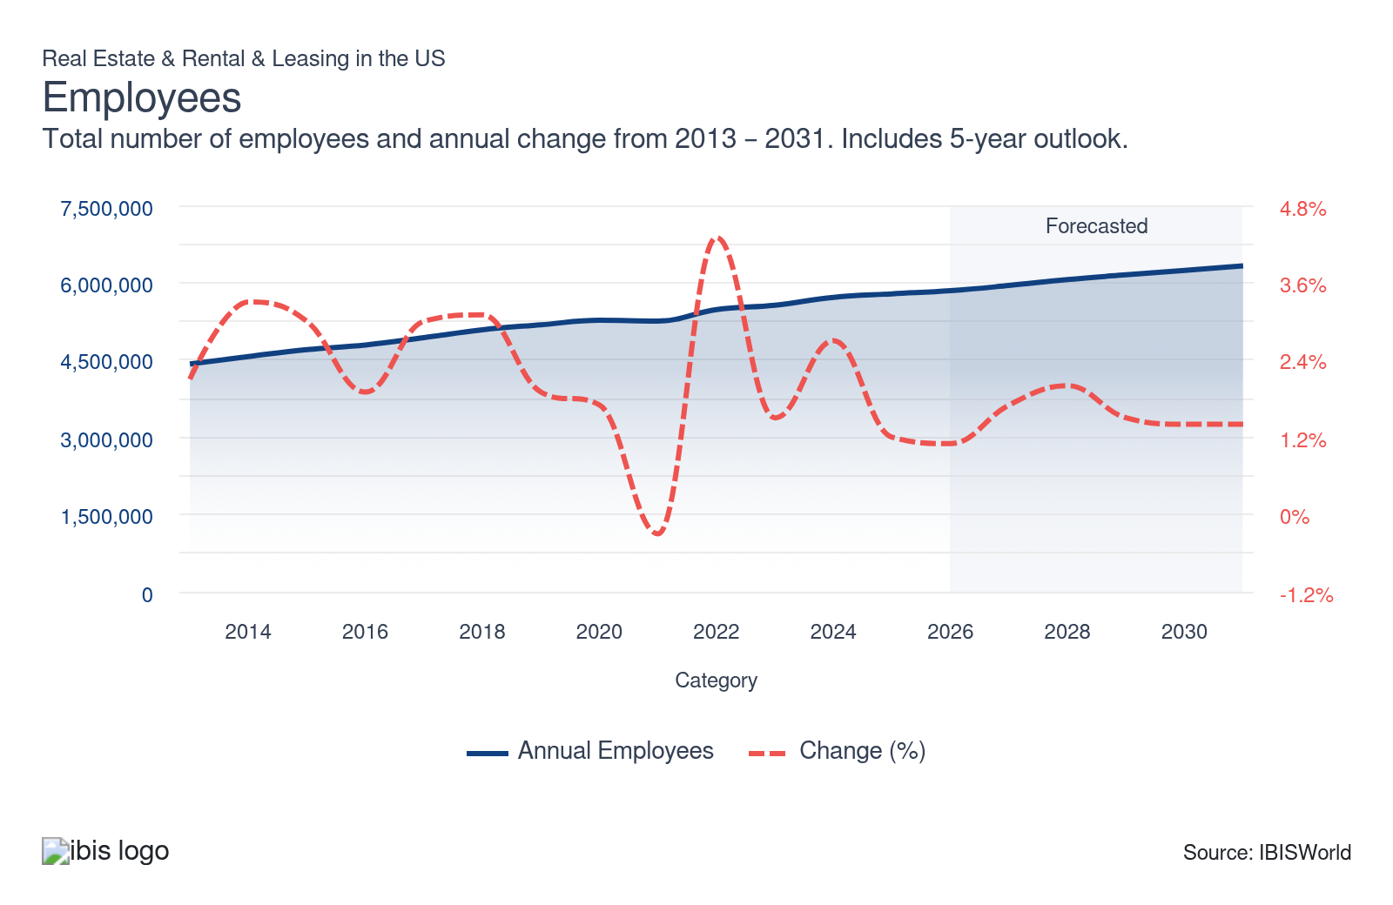
Businesses: | ↑ 2021-26 Business CAGR +1.5%
Businesses  4m  ’21-’26 ↑ 1.5 %  ’26-’31 ↑ 1.6 % | Employees per Business  2  ’21-’26 ↑ 0.6 %  ’26-’31 ↑ 0.0 % | Revenue per Business  $402.4k  ’21-’26 ↓ 0.2 %  ’26-’31 ↓ 0.0 %
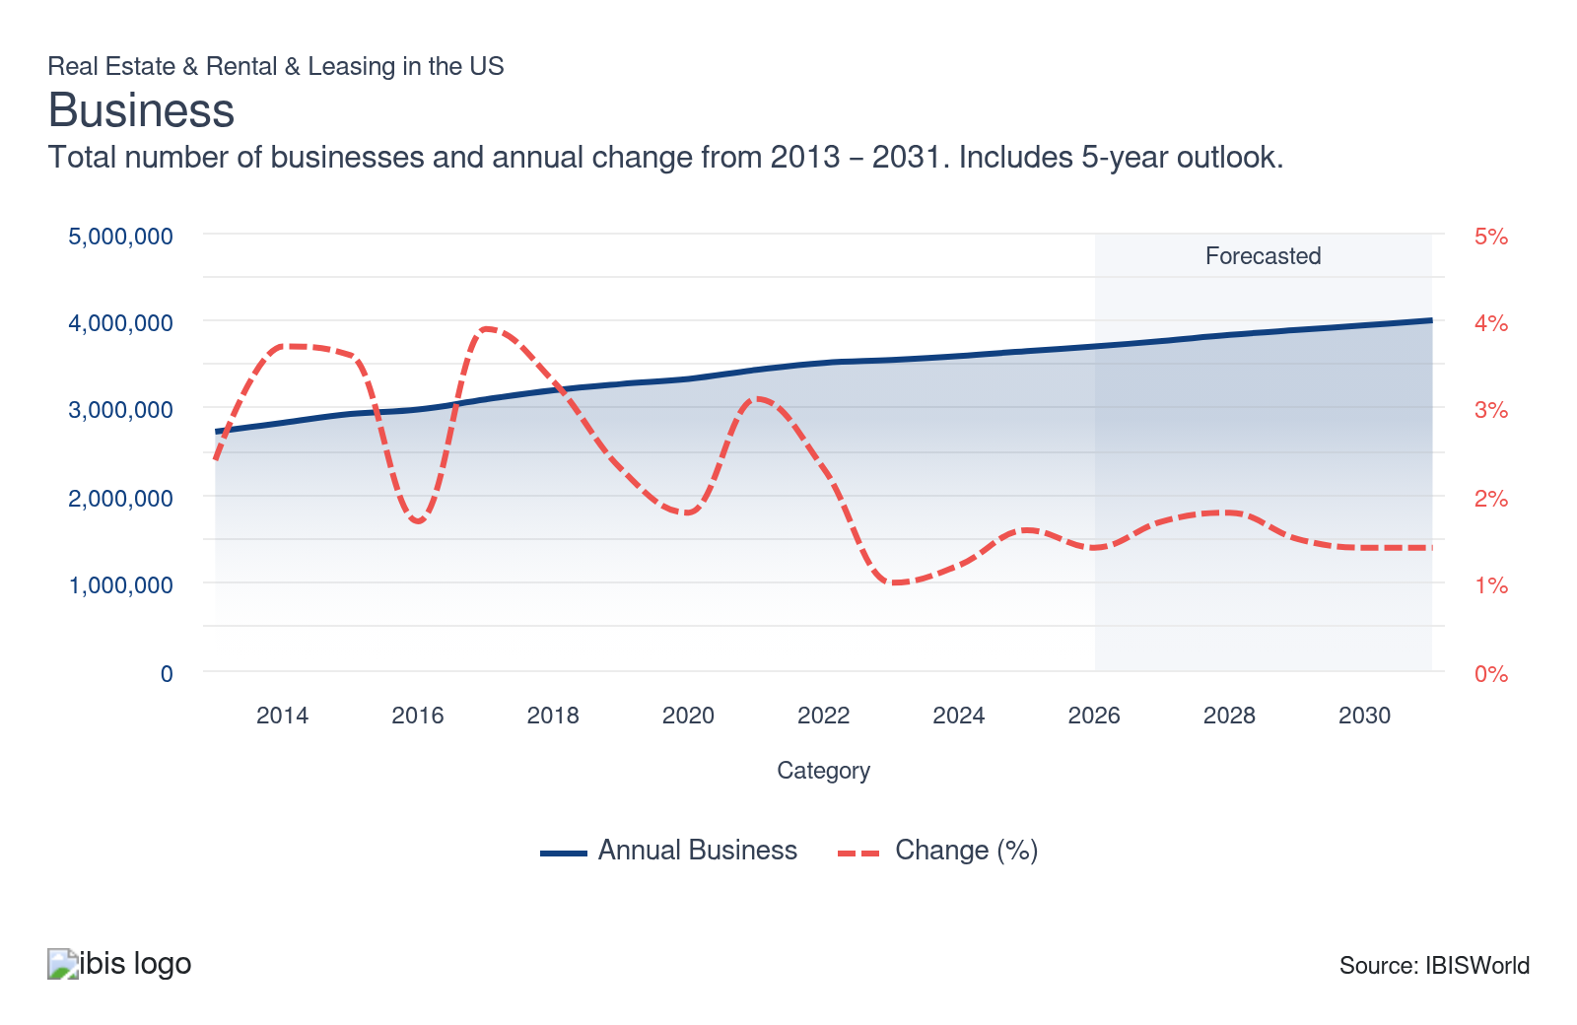
Profit: | ↑ 2021-26 Profit CAGR +1.8%
Total Profit  $730.7bn  ’21-’26 ↑ 1.8 % | Profit Margin  49.1%  ’21-’26 ↑ 1.3 pp | Profit per Business  $197.6k
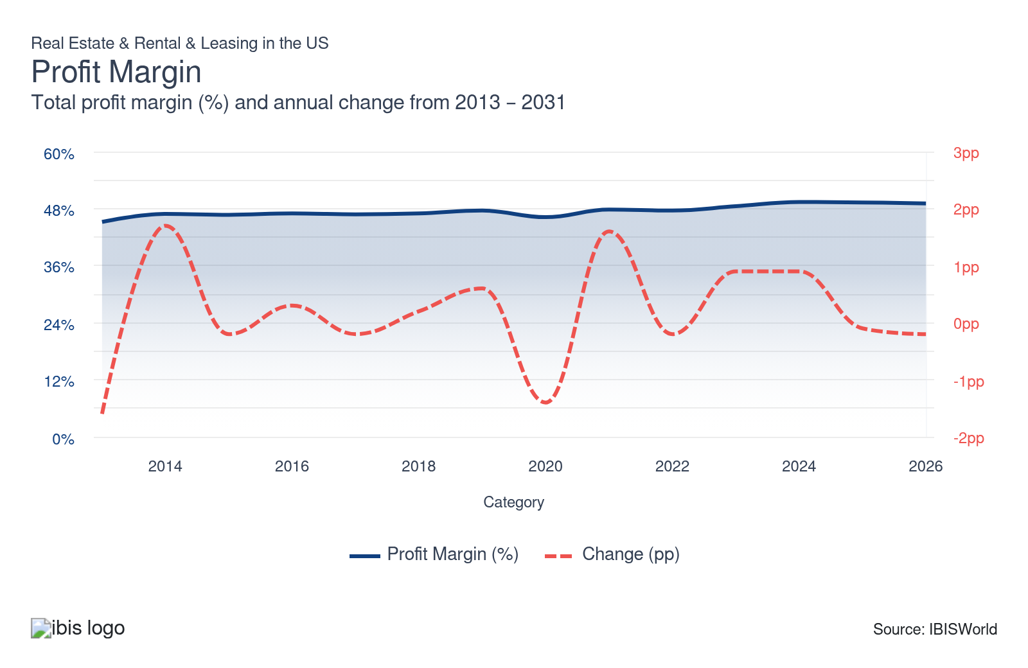
Current Performance
Current Performance

What's driving current industry performance?

Affordability issues cause demand to pivot
- Elevated home prices, higher mortgage rates, property insurance shocks and construction-cost inflation have locked many households out of ownership and made new-for-sale projects harder to undertake. According to the National Association of Realtors, existing home sales totals did not climb in 2025, totaling 4.06 million, the same as in 2024 and 0.7% below 2023. This has cooled transaction volumes, stretched marketing timelines and forced price cuts or incentives on some higher-end inventory, even as housing demand from demographics remains strong.
- Households priced out of buying often pivot to renting, particularly single-family rentals, build-to-rent communities and multifamily, keeping occupancy high and rents relatively firm even as rent growth moderates from pandemic-era peaks. Capital is following that shift: investors are favoring workforce housing, suburban rentals and markets where local incomes better support housing costs, while being more selective about luxury towers and urban condos.
- Large single-family rental and multifamily lessors are doubling down on value-oriented product, modest finishes, efficient layouts and amenity right-sizing to keep total monthly costs competitive while still supporting returns. Brokerages and proptech companies are investing in affordability tools (rate buydown programs, shared-equity and down-payment assistance partnerships, rent-to-own paths) to expand the buyer pool where possible.

Residential real estate and consumers power the sector
- Despite the confluence of negative factors impacting the housing market, such as elevated mortgage rates and a lack of supply, the climb in home values has bolstered industry revenue. According to data from the Federal Reserve Bank of St Louis, the median sales price of houses sold in Q1 2020 was $329,000; by Q2 2025, that figure had climbed to $410,800. Despite a recent drop in transaction volume, home price growth has bolstered residential real estate revenue.
- The lack of inventory is the most significant driver of home prices. Inflation and higher interest rates strengthen the cost of new home construction, contributing to the rising cost of homes. According to the NAR’s 2025 Profile of Home Buyers and Sellers, the share of first-time home buyers in 2025 dropped to a record low 21.0%, while the typical age for first-time buyers climbed to an all-time high of 40 years old.
- Rising per capita disposable income and e-commerce sales created significant demand for industrial real estate and freight transportation services. Truck rentals are a vital part of the freight transportation ecosystem and have benefited from the growth of e-commerce. According to the Federal Reserve Bank of St Louis, e-commerce retail sales climbed in 2025. E-commerce retail sales as a percentage of total sales reached 16.4% in the third quarter of 2025, surpassing the 16.3% peak in the second quarter of 2020.

Megaproject momentum spreads to equipment rental providers
- Megaprojects are becoming a much bigger slice of construction and industrial activity, and that shift is reshaping the heavy and industrial equipment rental subsector. A multi-year wave of enormous projects, semiconductor fabs, EV and battery plants, data centers, LNG terminals, grid and transmission upgrades and federally backed infrastructure jobs, is stacking up across the country under the IIJA, CHIPS Act, IRA and state programs. These projects require large volumes of earthmoving, lifting, power, pumps, climate control and site services equipment for years at a time, often beyond what contractors want to own outright.
- Large rental providers are seeing more long-duration, high-value contracts that stabilize utilization and justify bigger, more specialized fleets. Megaprojects are a key growth engine, with strong demand from verticals such as semiconductors, power, data centers and large transportation projects, supporting record rental revenues and elevated capex. Megaprojects also favor scale: only the biggest or best-organized rental providers can reliably supply, service and digitally manage fleets large enough for multi-billion-dollar sites.
- Leading rental firms are bulking up specialty divisions (power, HVAC, trench, shoring, pumps), co-locating branches near megaproject corridors and using telematics and centralized dispatch to orchestrate large fleets across sprawling sites. They are strengthening strategic relationships with national contractors and EPCs, designing project-specific solutions rather than one-off rentals and using the visibility of multi-year pipelines to plan capex, negotiate better OEM terms and lock in recurring revenue streams tied to the megaproject cycle.

As consumers spend more on rent, it indirectly boosts rental and leasing services
- According to a Moody's report, the average US renter household spends 30.0% of its income on rent.The percentage of disposable income allocated to rent has increased as market forces have fueled rising rental rates, outpacing growth in disposable income. While this statistic bolsters demand for apartment rentals and multi-family building construction, it also supports growth for several rental and leasing industries.
- According to the Federal Reserve Bank of New York's Household Debt and Credit Report, household debt reached $18.59 trillion in Q3 2025, with credit card balances, auto loan balances and delinquency rates all climbing. Household debt has grown steadily, with credit card and auto loan delinquencies signaling mounting consumer stress, particularly among lower-income borrowers, as high costs persist into 2026.
- Consumers who cannot afford expensive electronics or appliances turn to rental companies. This increases demand for rental services, boosting businesses' revenue. The number of people with poor or no credit or low-income households generally increases in a deteriorating economy. No-credit-needed offerings attract these individuals, thereby expanding the rental and leasing sector's customer base.

What influences industry volatility?

The job market and interest rates influence volatility
- Interest rate fluctuations significantly impact both renters and buyers. When interest rates climb, homeownership becomes less affordable, pushing more people toward renting. This can boost rental demand and potentially lead to higher rents. Conversely, lower interest rates might incentivize homeownership, reducing rental demand and potentially putting downward pressure on rents.
- A strong job market with rising wages can fuel demand for real estate, particularly in urban areas where employment opportunities are concentrated. Conversely, economic downturns with job losses can lead to increased vacancies and potentially lower rents.

Economic conditions dictate industry volatility
- Economic downturns can lead to decreased demand for construction and renovation projects, impacting rental activity. Conversely, economic booms might see increased demand and potentially strain equipment availability.
- Higher interest rates can make equipment purchases more expensive, potentially driving customers to rent as a more affordable option. However, it can also lead to decreased business investment and project delays, impacting demand.
- Federal deregulation under President Trump’s second term has favored energy, extraction and some industrial activity, but it has not yet, on its own, produced a broad, dramatic surge in heavy and industrial equipment rental demand. Multiple executive actions in 2025 streamlined permitting, reopened federal lands and offshore areas for drilling, loosened certain environmental reviews and created new tax incentives for domestic production, all of which lower regulatory and cost barriers for oil and gas, mining and manufacturing projects that rely heavily on rented equipment. However, the actual project start and equipment utilization still depend on commodity prices, financing costs and global demand, which remain mixed.
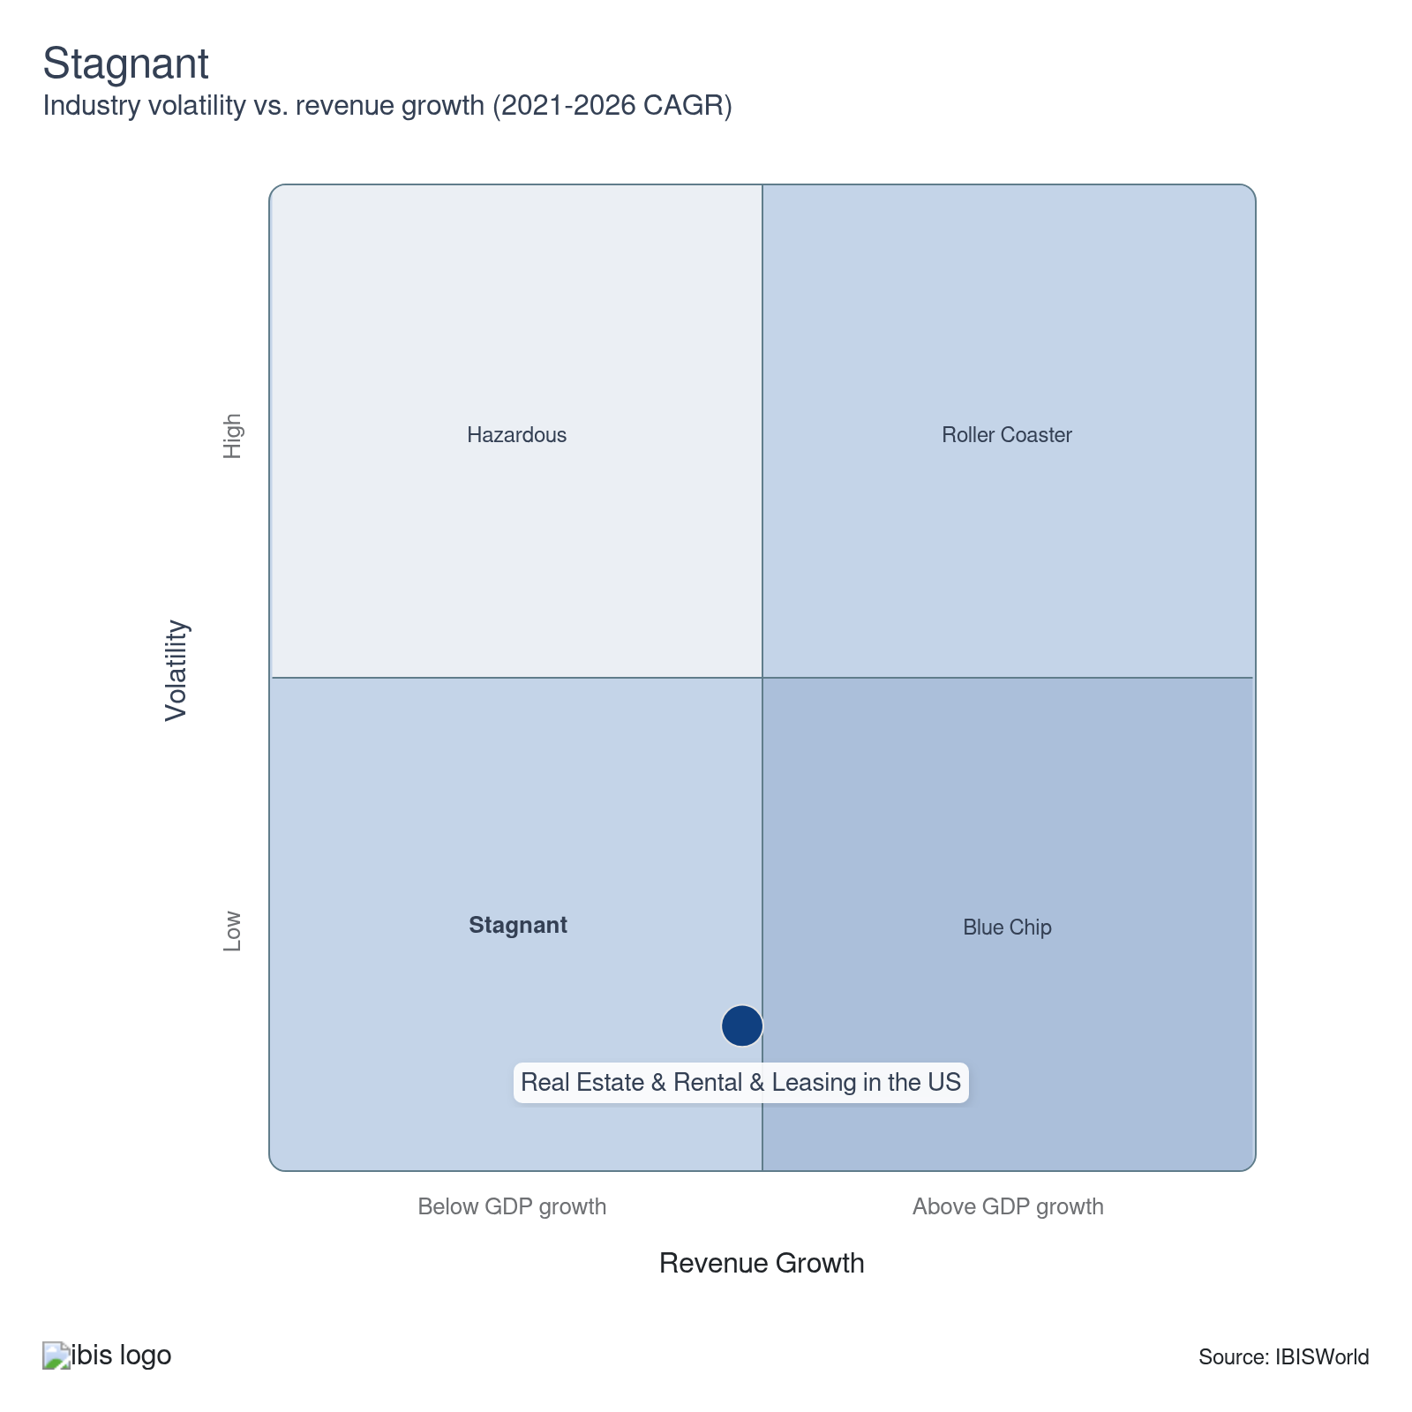

How do successful businesses overcome volatility?
Access secure revenues
Accessing secure, contract-based or recurring revenues cushions companies against swings in spot demand. This stability supports planning, debt service and fleet investment, allowing them to ride out downturns without drastic rate cuts or under-maintenance.
Adapt quickly to changing regulations
Adapting to changing regulations enables real estate companies to navigate market volatility. It allows them to stay compliant while optimizing their business strategies, minimizing legal and financial risks and maintaining a competitive edge in the ever-changing landscape.
Outlook | ↑ 2026-31 Revenue CAGR +1.6%

What's driving the industry outlook?

The housing market will stay tight and bifurcated
- Home prices will remain far above pre-2019 levels, mortgage rates will stay structurally higher than the 2020–2021 lows and even with some inventory gains, most markets still face meaningful shortfalls of reasonably priced homes, especially for first-time and middle-income buyers. New construction will add units, but constraints around labor, zoning, materials and financing mean the supply gap will only close slowly.
- Ownership will remain hardest for first-time and moderate-income buyers, keeping home sales below historic norms and pressuring traditional brokerages and higher-end for-sale products. At the same time, rentals, especially single-family rentals, workforce apartments and build-to-rent, will benefit from durable demand as households that can’t or won’t buy stay in the renter pool longer, supporting occupancy and relatively firm rents even if rent growth moderates. Markets with more flexible land use and lower costs (many Midwest and Southern metros) are positioned to capture outsized population and investment flows.
- Large landlords and SFR operators are focusing on operational efficiency and modestly priced products to keep total monthly costs competitive while preserving profit. Brokerages and fintech/proptech players will lean into affordability tools, rate buydowns, shared equity, down-payment assistance and rent-to-own light models to expand the buyer pool at the margin.

High and climbing equipment ownership costs will make equipment rental more attractive
- According to the National Association of Manufacturers' (NAM) Q3 2025 Outlook Survey, manufacturers expect raw material and other input costs to climb 5.4% over the next 12 months. Purchase prices, financing costs, maintenance and compliance expenses for heavy and industrial machinery will keep climbing, especially as new models add emissions controls, electrification and digital systems. Owning a modern fleet increasingly ties up large amounts of capital and exposes businesses to technology obsolescence and uncertain resale values.
- Rental will look even more attractive as a financial and operational strategy. Renting lets firms convert big capex outlays into predictable operating expenses, shift maintenance and residual-value risk to rental providers and access newer, compliant machines only when needed.
- Rental companies will assume a steadily larger share of the equipment ownership burden, investing in cleaner, more specialized fleets, telematics and predictive maintenance to spread rising costs across a broad user base. They will expand subscription and on-demand models that give customers flexible access with transparent pricing. Contractors and industrial firms, for their part, will benefit from formal rent vs. own policies, deeper preferred-supplier partnerships and integrated planning tools that optimize fleet mix, owning a smaller core and relying on rentals to handle peaks, megaprojects and fast-changing technology requirements.

Rental and leasing providers bolster their omnichannel presence
- According to Nielsen and IMF data, by 2025, nearly 60.0% of households will be omnichannel shoppers. Customers expect to research products online, compare prices and potentially purchase in-store or on their mobile devices, requiring a unified experience across all touchpoints.
- Being present across multiple channels makes it easier for customers to access the business. Whether they’re on a company's website, mobile app, phone call, social media, or even physical store, the lease or rental process can be initiated or completed. An omnichannel approach helps automate and streamline operations such as booking, payments and customer service, resulting in greater operational efficiency.
- Major consumer rental providers, Aaron's, Prog Holdings and Rent-A-Center mentioned accelerating their omnichannel strategies in their annual reports. The push toward e-commerce and app-based rentals will climb over the next five years as rental providers seek to expand their market reach. Continued investment in unified commerce platforms, moving beyond omnichannel to fully synchronized inventory, pricing and customer data, will be critical to compete in a market where customers increasingly demand buy-anywhere, fulfill-anywhere flexibility.

The internet poses both a challenge and an opportunity
- Home sellers looking to save money and expand their profit from sales will become more comfortable listing properties using websites like Zillow, StreetEasy and LoopNet. These websites allow homeowners to market their homes to a far-reaching audience. According to the National Association of Realtors, in 2025, for-sale-by-owner (FSBO) sales accounted for 5.0% of homes sold in the US, down from 6.0% in 2024.
- The Internet also challenges the rental and leasing industries. For example, the car-sharing marketplace Turo allows individual car owners to list their vehicles for rent on a peer-to-peer platform, essentially removing potential customers from traditional rental companies. Several apps also exist for tool and equipment rental, which also remove potential customers from traditional rental providers. However, these apps pose a greater threat to rental companies that focus on consumer markets.
- Online marketing platforms, such as Google Ads, Facebook Ads, or LinkedIn Ads, enable businesses to reach a larger audience at a lower cost than traditional advertising methods. The internet allows companies to gather data about customers' preferences, behaviors and profiles. This information can be used to tailor its services and marketing strategies to individual needs, attracting and retaining more customers.
Life Cycle | Mature

Why is the industry mature?

Contribution to GDP
The Real Estate and Rental and Leasing sector’s stable, sizable GDP contribution reflects its entrenched role in the economy, with steady demand across housing, commercial properties and equipment leasing. Its consistent output and integration with broader financial activities signal maturity, as growth aligns with overall economic trends rather than rapid expansion or disruption.

Market Saturation
The sector’s market saturation reflects maturity, with stable competition and established supply-and-demand dynamics and rental and leasing markets experiencing limited disruptive growth. High saturation in key markets signals entrenched players, balanced inventory and pricing influenced by cyclical demand rather than rapid expansion, indicating a well-developed industry operating near equilibrium.

Innovation
The sector's focus on incremental innovations such as PropTech and sustainability upgrades, rather than disruptive breakthroughs, reflects maturity as established players optimize existing models. While AI and blockchain enhance efficiency, adoption remains gradual, emphasizing refinement over radical change. This measured approach to innovation prioritizes stability and integration with entrenched systems, characteristic of a mature industry that adapts within set paradigms.

Consolidation
In the Real Estate and Rental and Leasing sector, consolidation manifests through mergers of property management firms, corporate landlords amassing large portfolios (e.g., single-family rentals) and institutional investors acquiring smaller operators. This reduces competition, centralizes asset control and standardizes lease terms, reflecting mature markets where dominant players optimize efficiency and market share through scale, not expansion.

Technology and Systems
The sector’s tech adoption- PropTech platforms, AI-driven analytics and blockchain transactions- reflects maturity through optimized, incremental enhancements rather than disruptive overhauls. Established players integrate tools such as VR tours and IoT to improve efficiency, prioritizing stability and scalability over radical innovation. This focus on refining existing systems over pioneering new models underscores entrenched operational maturity and market equilibrium.

4. Products and Markets
https://my.ibisworld.com/us/en/industry/53/products-and-markets
Largest Market  $1.1tr  Real estate | Product Innovation  Moderate

Key Takeaways
- The sector’s outlook is resilient but structurally bifurcated between ownership and rental. Persistently tight for-sale supply, higher-for-longer rates and rising equipment ownership costs will favor rental models across housing, industrial assets and machinery, rewarding rental providers that prioritize efficiency, flexibility and value-oriented offerings.
- Consumers are embracing rentals and leasing as a way to access goods without heavy debt. From autos to electronics and household items, short-term or no-credit-needed options appeal to households facing higher living costs and tighter credit conditions.

Products and Services
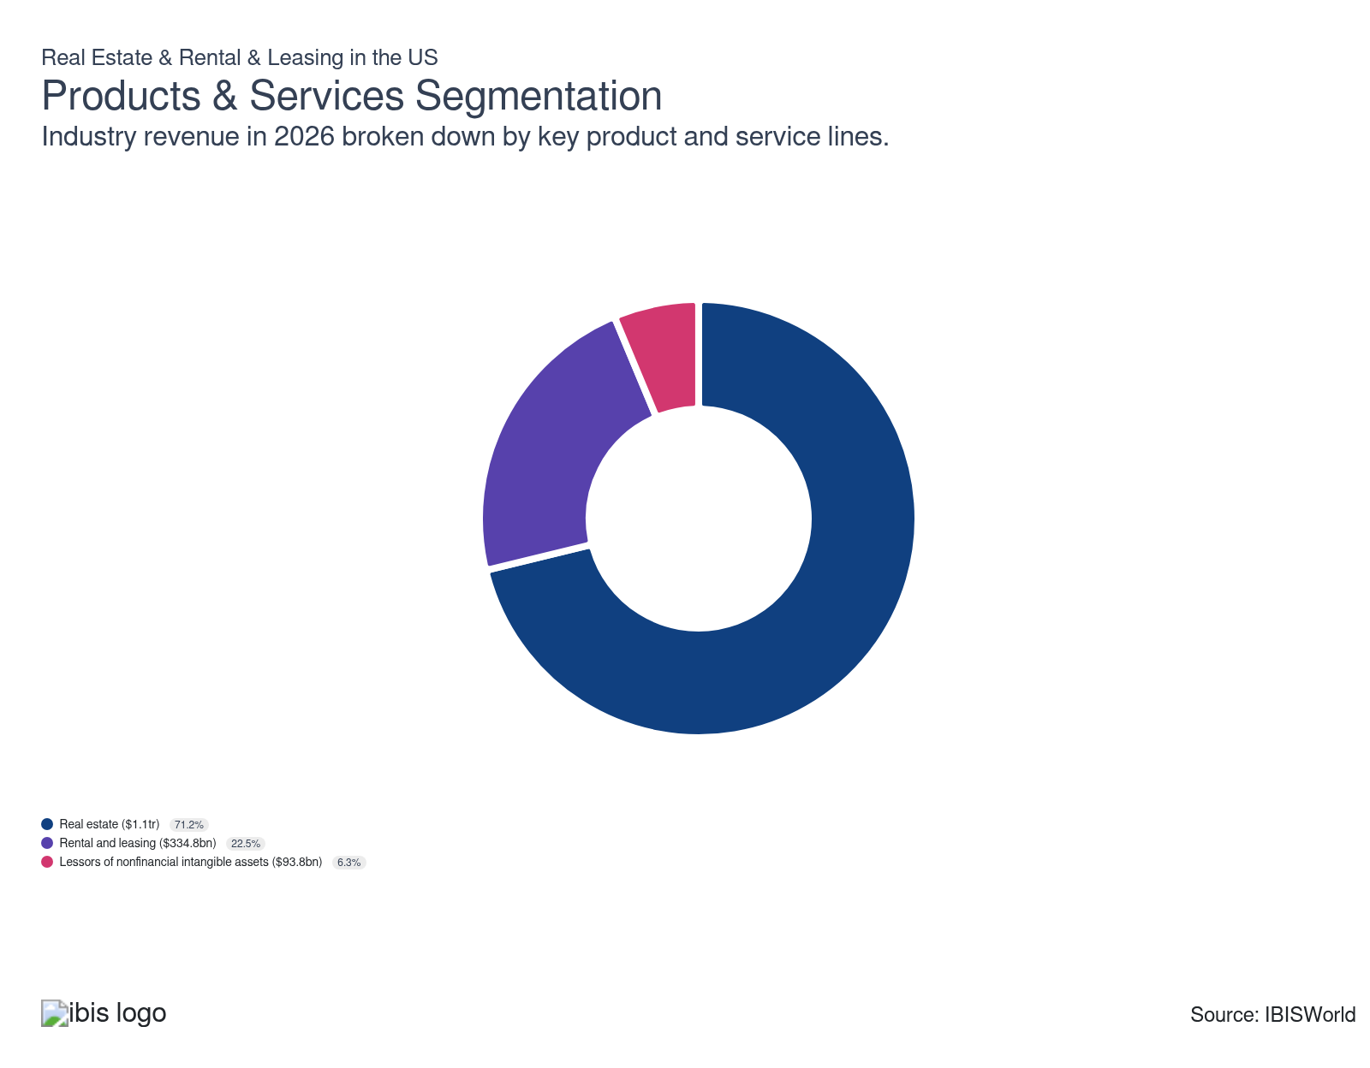

How are the industry’s products and services performing?

Affordability pressures hurt some corners of the real estate subsector while creating tailwinds for others
- The Real Estate subsector primarily involves the sale, rental and leasing of real estate. It also includes selling, buying or renting real estate for others.
- Soaring home prices, elevated mortgage rates, insurance spikes and construction-cost inflation have pushed homeownership out of reach for a large share of households, with national measures showing record-low purchase affordability and more than half of households unable to afford even a $300,000 home. This weakens transaction volumes for traditional for-sale brokers and slows some market-rate development.
- At the same time, the widening cost gap between owning and renting has boosted demand for rentals, especially single-family rentals and well-located multifamily, supporting high occupancy and rent resilience even as some markets see modest softening. These dynamics also channel capital toward build-to-rent, workforce housing and value-add rental strategies that directly monetize the affordability squeeze.

High costs push businesses and consumers toward rental and leasing
- Rental and Leasing services include tangible assets such as automobiles, computers, consumer goods and industrial machinery.
- In 2025, demand for rental and leasing services rose because renting was a flexible way to access assets in a still-uncertain, high-cost environment. Businesses leaned more on renting industrial machinery and light construction equipment as interest rates and tighter credit made outright purchases less attractive, while infrastructure, manufacturing and logistics projects sustained baseline demand.
- Consumers, meanwhile, drove growth in auto rental and other consumer-goods leasing as travel normalized and many households chose short-term access over long-term debt. Across categories, structural factors, digital platforms that make it easier to rent, rapid technology cycles that favor leasing over owning electronics and corporate focus on balance-sheet light models, reinforced the appeal of rentals,

Lessors of nonfinancial intangible thrive as brands and tech go asset-light
- Lessors of nonfinancial intangible assets provide companies with non-produced assets through contract rights, leases and licenses. As businesses look to expand operations, they will likely need to acquire some contract, lease or license. Intangible asset lessors grant clients the right to use the intangible asset they need, often for a royalty or licensing fee paid to the asset holder.
- Demand for lessors of nonfinancial intangible assets rose in 2025 as more companies sought to monetize ideas, technology and brands rather than just physical assets. As business models continued shifting toward software, platforms and data, firms increasingly relied on licensing patents, proprietary technologies, trademarks and franchises to expand into new markets without heavy capital outlays. This supported growth in sectors such as technology, pharmaceuticals, consumer brands and franchised services, where licensing allows rapid scaling while keeping balance sheets relatively light.
- At the same time, many companies facing higher financing costs and economic uncertainty looked to generate recurring, asset-light revenue streams from their existing intellectual property, strengthening the case for specialist lessors and licensing entities that aggregate and manage intangible portfolios. Growing complexity in areas such as royalty accounting, global IP protection and cross-border tax planning also encouraged businesses to outsource or formalize their licensing structures through dedicated lessors rather than handle everything in-house.

What are innovations in industry products and services?

Tech-driven experiences are becoming more prevalent
- The swell of tech-driven experiences is transforming the real estate, rental and leasing sector by enhancing efficiency, accessibility and customer expectations. Proptech innovations like virtual tours (VR/AR) and IoT-enabled smart buildings streamline property viewings and management, reducing costs and expanding market reach. AI-driven analytics optimize pricing, maintenance and tenant matching, while blockchain secures transactions and simplifies leases.
- These tools improve tenant satisfaction through personalized, data-informed services and sustainability via energy-efficient systems. However, they also pressure traditional firms to adopt digital tools or risk obsolescence, as tech-savvy players leverage automation and real-time insights to dominate markets. The shift toward digital-first interactions reshapes competition, prioritizing firms that integrate seamless omnichannel experiences and predictive analytics into their operations.

Online reservation and booking systems, self-service kiosks and automated pickup/drop-off streamline the rental process
- Online reservation systems, self-service kiosks and automated pickup/drop-off services are transforming the sector by enhancing operational efficiency and tenant satisfaction. Online booking platforms streamline property viewings, lease signings and maintenance requests, reducing vacancies and administrative burdens. Like hospitality models, self-service kiosks enable 24/7 check-ins/check-outs, secure payments and upsell opportunities (e.g., storage upgrades), improving accessibility and reducing staffing costs.
- Automated pickup/drop-off for keys or equipment (e.g., moving trucks) minimizes friction in rental processes, while IoT integration provides real-time asset tracking. These tools cater to tech-savvy tenants, offering convenience and personalization, which drive loyalty and competitive differentiation. By automating routine tasks, firms reallocate resources to strategic growth initiatives, such as sustainability initiatives or portfolio expansion, thereby ensuring adaptability in a digital-first market.

What products or services do successful businesses offer?
Be an early adopter of new technologies
Companies in this sector can gain a market advantage by offering ready-made products with the latest designs and models.
Manage a high-quality assets portfolio
Tenants prefer properties in prime locations and tenant demand is less volatile. Lessors should have the skills to identify local economic, demographic and social trends.

Major Markets
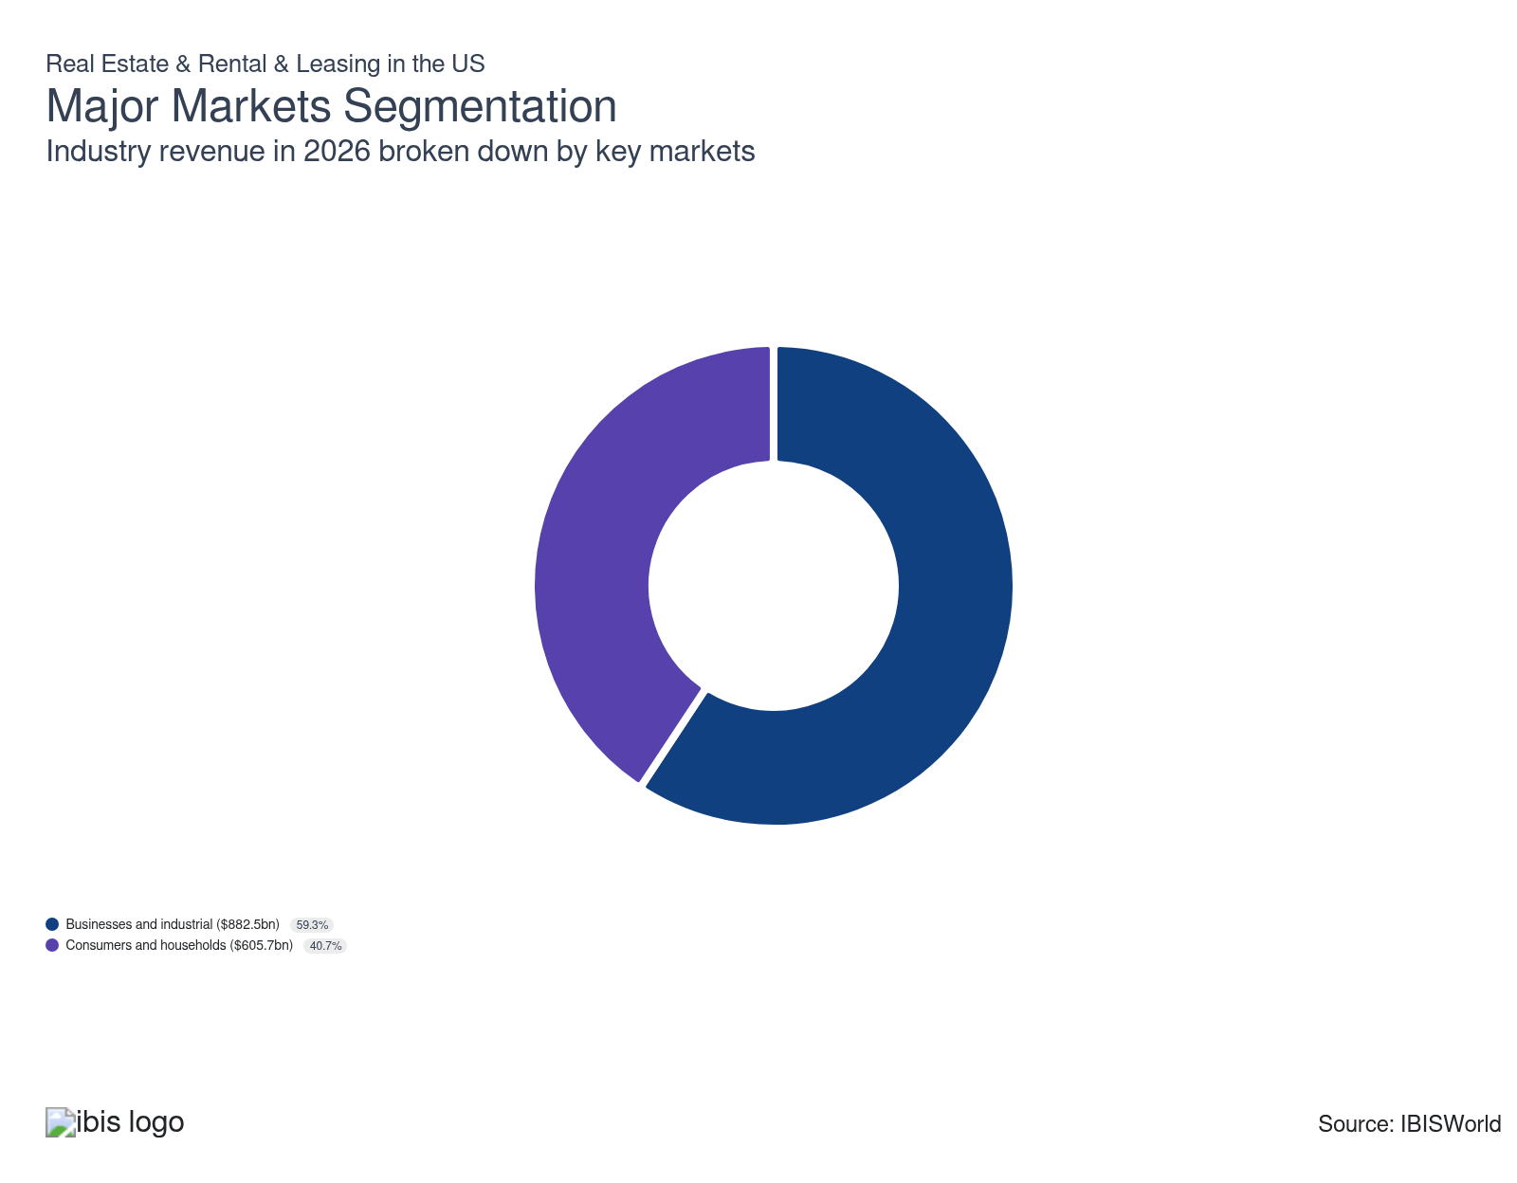

What’s influencing demand from the industry’s markets?

Megaprojects increasingly power the business and industrial market
- The business and industrial market segment includes leasing and renting construction equipment, tools, industrial equipment, trucks and cars. The commercial market comprises office, retail, manufacturing and warehouse facilities. The sale of multifamily residential properties or apartment buildings to companies intending to generate income from the property is also included in this segment. Businesses are also the leading licensors of intellectual property.
- The wide variety of real estate rental and leasing activities businesses undertake prevents a significant overall drop in demand. Commercial real estate activity climbed in 2025, but from a depressed base and unevenly across sectors. Transaction volumes and investment picked up meaningfully as interest rates stabilized and price expectations between buyers and sellers narrowed. Multifamily, industrial and retail showed the strongest recovery in sales and leasing, while office lagged and remained structurally weak.
- Demand for equipment rental climbed in 2025 mainly because large construction and industrial pipelines stayed active while financing conditions stabilized. Public infrastructure spending, manufacturing reshoring, data centers, energy projects and warehousing/logistics construction kept contractors busy, so they expanded their use of rental equipment rather than buying equipment outright to preserve cash and manage project-specific needs.

The consumer and household segment powers the real estate subsector
- The real estate subsector predominantly involves renting, managing and selling real estate to consumers. Consumers are also the primary market for car rental, electronics and appliance rentals, formal wear and costume rentals, DVD rentals and game and video rentals.
- According to the National Association of Realtors, existing home sales stagnated at 4.06 million in 2025, down only 1,000 units from 2024 levels. Despite the stagnation in existing home sales, the median national home price gained 1.7% in 2025. Despite rising home values and elevated mortgage rates, the high prices keep many buyers out of the market, prolonging household renting and stimulating demand for apartment rentals, which benefits the industry.
- According to the Auto Rental News Factbook, the car rental industry enjoyed a 4.4% gain in revenue in 2025. The climb was driven by upper and middle-class travelers taking more domestic trips. Shorter appliance lifespans and rising repair costs are increasingly pushing consumers toward appliance rentals, benefiting the sector.

International Trade

Some industries don't directly import or export goods. See reports at the manufacturing level for international trade data on relevant products.

5. Geographic Breakdown
https://my.ibisworld.com/us/en/industry/53/geographic-breakdown

Key Takeaways
- California anchors Western real estate and equipment demand. Its large, affluent population, expensive housing and global gateway metros drive high transaction volumes and a constant need for construction and industrial equipment rentals.
- Texas and the broader Southwest are emerging as high-growth platforms. Substantial population and job growth, favorable tax and regulatory regimes and robust energy and mining activity attract capital to both real estate and equipment rental providers.

Business Locations
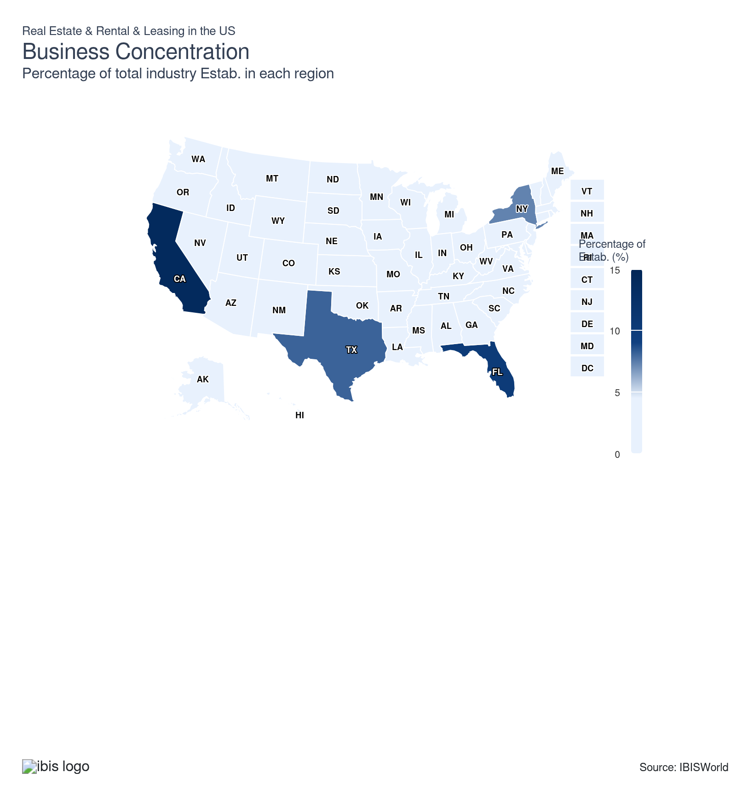
State | Estab.  Units | Estab.  % | Population  %
California | 65433 | 1.7 | 11.5
Florida | 47102 | 1.2 | 7.0
Texas | 37714 | 1.0 | 9.4
New York | 34072 | 0.9 | 5.8
North Carolina | 15388 | 0.4 | 3.3
Georgia | 15158 | 0.4 | 3.3
Colorado | 14558 | 0.4 | 1.8
Illinois | 13984 | 0.4 | 3.7
Washington | 13701 | 0.4 | 2.3
Arizona | 12689 | 0.3 | 2.2
Ohio | 11606 | 0.3 | 3.5
Pennsylvania | 11622 | 0.3 | 3.8
Virginia | 11488 | 0.3 | 2.6
New Jersey | 10179 | 0.3 | 2.8
Michigan | 9057 | 0.2 | 3.0
Massachusetts | 8260 | 0.2 | 2.1
Minnesota | 7835 | 0.2 | 1.7
Indiana | 7463 | 0.2 | 2.0
Maryland | 7491 | 0.2 | 1.8
Missouri | 7279 | 0.2 | 1.8
Oregon | 7500 | 0.2 | 1.2
South Carolina | 7542 | 0.2 | 1.6
Tennessee | 7008 | 0.2 | 2.1
Utah | 6854 | 0.2 | 1.0
Alabama | 5035 | 0.1 | 1.5
Louisiana | 5523 | 0.1 | 1.3
Nevada | 5546 | 0.1 | 1.0
Wisconsin | 5588 | 0.1 | 1.7
Oklahoma | 4725 | 0.1 | 1.2
Kentucky | 4308 | 0.1 | 1.3
Arkansas | 3514 | 0.1 | 0.9
Idaho | 3740 | 0.1 | 0.6
Iowa | 3535 | 0.1 | 0.9
Kansas | 3604 | 0.1 | 0.9
Connecticut | 3269 | 0.1 | 1.1
Nebraska | 2663 | 0.1 | 0.6
Mississippi | 2534 | 0.1 | 0.9
Montana | 2512 | 0.1 | 0.3
New Mexico | 2499 | 0.1 | 0.6
Hawaii | 2081 | 0.1 | 0.4
Maine | 2091 | 0.1 | 0.4
Delaware | 1427 | 0.0 | 0.3
District of Columbia | 1496 | 0.0 | 0.2
New Hampshire | 1514 | 0.0 | 0.4
Rhode Island | 1263 | 0.0 | 0.3
South Dakota | 1357 | 0.0 | 0.3
West Virginia | 1373 | 0.0 | 0.5
Wyoming | 1392 | 0.0 | 0.2
Alaska | 1140 | 0.0 | 0.2
North Dakota | 1128 | 0.0 | 0.2
Vermont | 816 | 0.0 | 0.2

Where are industry businesses located?

California dominates the West region
- California boasts the largest population in the US and a pricey housing market, making it an excellent location for real estate companies. According to Redfin data, California had the top six most expensive metros in the US in 2025.
- The state’s nearly 40-million population, economy and concentration of high-wage industries generate constant transaction volume across residential, multifamily, industrial and office assets, which supports brokerage, lending, development and proptech revenues. Global capital also treats Los Angeles, San Francisco and San Diego as gateway markets, so firms that locate there sit close to institutional investors and foreign buyers, reinforcing deal flow and brand visibility.
- Massive public and private construction pipelines across transportation, energy, housing, warehousing and ports require continuous access to earthmoving, lifting and specialty equipment, making local rental yards essential for serving contractors quickly and cost-effectively. California’s status as the nation’s largest logistics and trade hub, anchored by the Los Angeles/Long Beach and Oakland port complexes and a dense highway and rail network, also concentrates industrial projects, distribution centers and infrastructure upgrades. Hence, they want nearby fleets to minimize transport time, mobilization costs and downtime.

Population growth in Texas has led to an increasing share of companies in the Southwest
- Population and job growth, driven by relocations of firms in technology, energy, healthcare and manufacturing, keep housing, industrial and office demand expanding in metros like Dallas–Fort Worth, Austin, Houston and San Antonio, creating steady transaction volume and development pipelines.
- At the same time, Texas offers no state income tax, relatively low overall tax burdens and generally light, predictable regulation, which support higher after-tax returns and make large projects easier to entitle and finance, attracting both institutional capital and operating platforms that want scalable portfolios in a market with strong rental yields, continued in-migration and room for new construction.
- According to data from the US Geological Survey, Nevada, Arizona and Texas rank among the top three US states in terms of the value of nonfuel minerals produced. The robust oil, gas and mineral extraction in the Southwest region stimulates significant demand for equipment rental and leasing companies.

High concentration of the population in the Southeast provides sustained downstream demand
- Florida and Georgia both have large populations. Like California, companies have opportunities in these Southeast markets.
- Atlanta and Miami are both hotspots for housing and new construction. Along with bustling economic activity, these cities provide ample downstream demand for real estate rental and leasing. In 2025, Florida saw weaker demand as high mortgage rates, insurance costs and already-elevated prices made homes less affordable and inventory remained above pre-pandemic norms after a construction boom and slower migration. That combination produced softer conditions and localized price declines, especially in condos and areas competing with substantial new construction.
- Unlike regions with harsh winters, Florida experiences relatively stable weather conditions, allowing construction projects to continue year-round and maintaining a consistent demand for rental equipment. Hurricanes frequently impact Florida, resulting in large-scale reconstruction efforts that require significant rental equipment for debris removal, rebuilding and repairs.
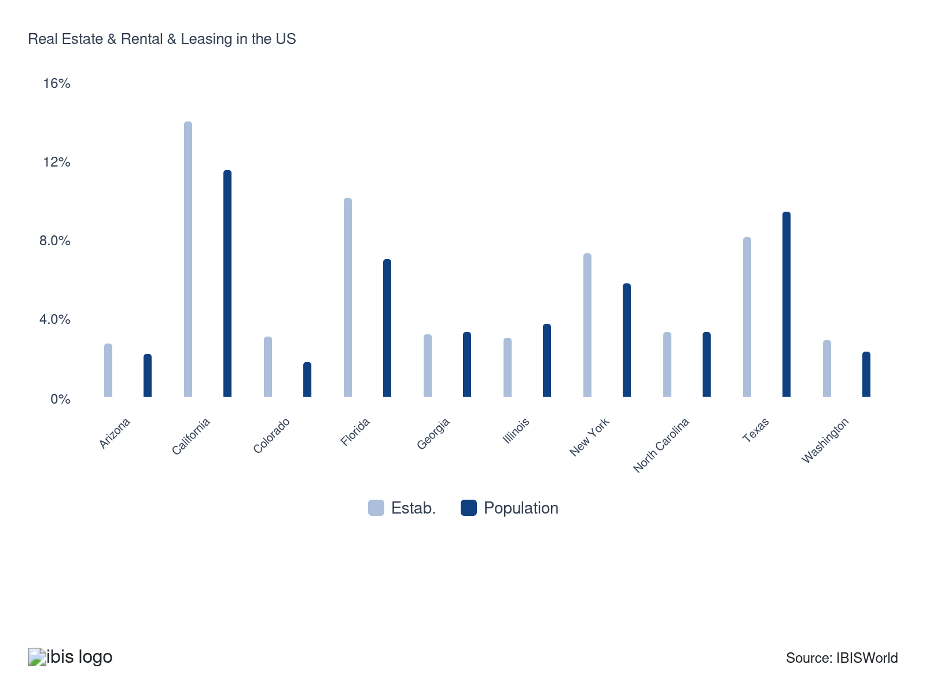

How do businesses use location to their advantage?
Ensure accessibility to consumers and end-users
Companies that are more accessible to their consumers will have an advantage over competitors who are remote or difficult to reach. Customers, more often than not, choose services that are convenient and easily accessible to them.
Be willing to outsource when appropriate
Outsourcing allows real estate companies to optimize operations in different locations without establishing their presence. Companies can adapt to local markets more efficiently, minimizing costs, maximizing customer reach and leveraging geographical advantages.

6. Competitive Forces
https://my.ibisworld.com/us/en/industry/53/competitive-forces

Key Takeaways
- High borrowing and equipment costs are steering businesses toward renting rather than owning hard assets. Firms increasingly rely on equipment and vehicle rentals to stay flexible, preserve cash and avoid technology and residual-value risk in a volatile cost environment.
- Rental and leasing providers are leaning into digital and omnichannel strategies to capture demand. Firms are expanding app-based rentals, unified commerce platforms and affordability tools to reach price-sensitive consumers and deliver seamless, buy-anywhere, fulfill-anywhere experiences.

Concentration
Low
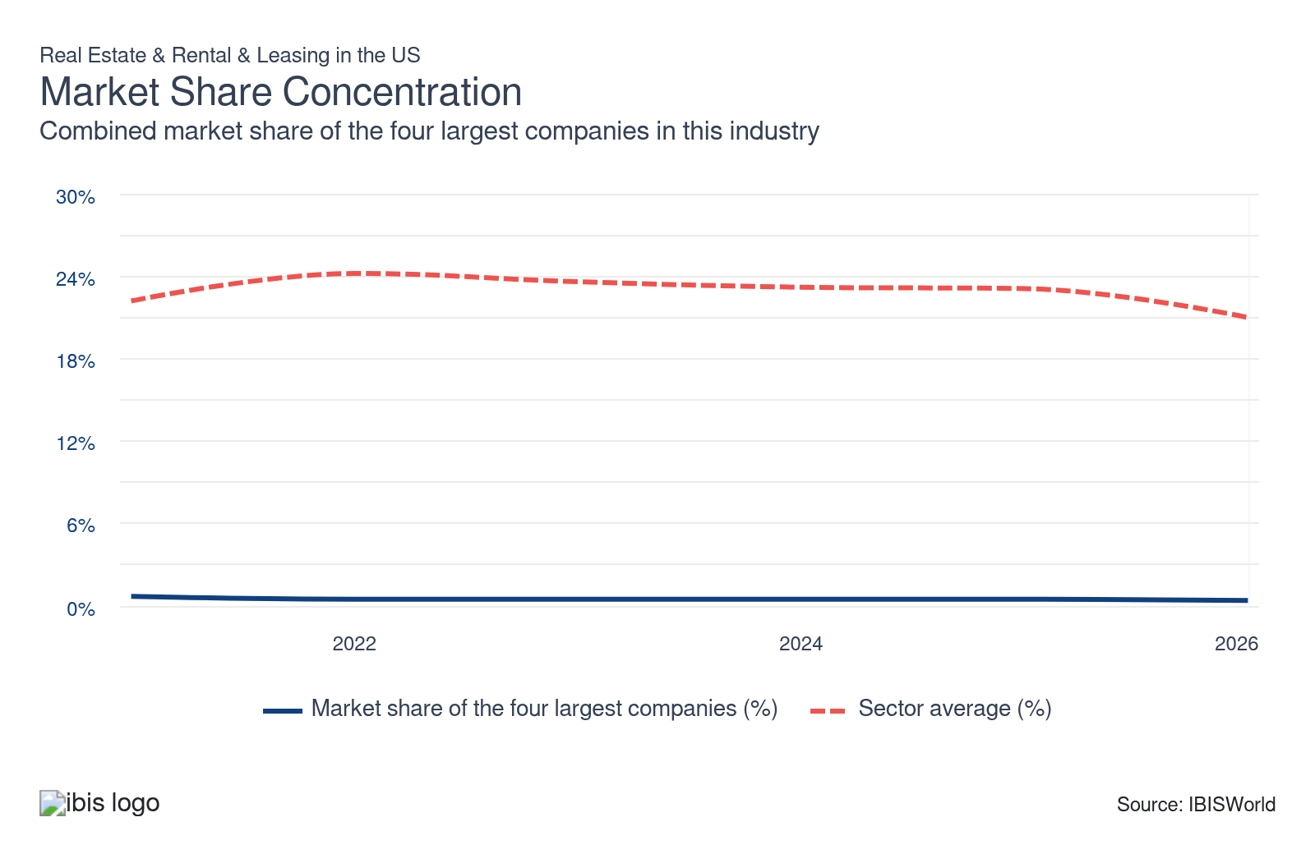

What impacts the industry’s market share concentration?

Concentration in the Real Estate subsector is very low
- Market share concentration in the real estate sector remains low because of fragmented participation and high entry of small-scale operators. The industry’s labor structure, with most licensees being salespeople rather than brokers, reflects a decentralized system favoring localized, independent agents.
- Low barriers for individual agents and regional market variability (e.g., Dallas and Houston’s high transaction volumes vs. Los Angeles’ lower turnover) prevent large-scale consolidation. This fragmentation is sustained by diverse buyer preferences and regulatory frameworks that encourage competition among small players rather than corporate dominance.

The Rental and Leasing subsector's fragmented structure limits concentration
- The equipment rental sector exhibits low market share concentration because of its decentralized, localized nature and high entry of small-to mid-sized rental providers. While top players like United Rentals and Sunbelt Rentals lead, their combined market share remains limited, reflecting a landscape populated by regional and specialized firms.
- The industry’s low barriers to entry, such as accessible equipment financing and minimal regulatory hurdles, enable smaller players to compete, particularly in niche markets like event equipment or specialized machinery. Diverse customer needs across construction, industrial and consumer segments foster competition among localized providers rather than consolidation under a few corporations.
- In the past year, large M&A, especially Herc Rentals’ roughly $5.3 billion deal to acquire H&E Equipment Services, increased concentration by combining two sizable national fleets and footprints in the rental market.

Demand-driven fragmentation lowers concentration
- Market concentration is diluted by project-specific demand variability and preferences for localized service providers. Construction and industrial clients often prioritize proximity and tailored solutions, favoring regional rental companies over national chains.
- The sector’s capital-intensive nature also limits rapid consolidation, as acquiring modern, eco-friendly fleets requires significant investment, deterring monopolistic growth. Rising rental penetration and infrastructure investments amplify opportunities for smaller entrants, sustaining a competitive ecosystem where no single player dominates.

How do successful businesses handle concentration?
Conduct market research
Nonemployers and small businesses can succeed by focusing their research and efforts regionally. Knowing and adapting to regional needs is crucial for success.
Develop a skilled labor force
Skilled professionals can analyze market trends, identify potential tenant demographics and develop targeted marketing strategies. This helps attract new tenants and stay competitive even in a concentrated market.

Barriers to Entry
Low | Steady

What challenges do potential industry entrants face?

Legal
- Legal challenges include title disputes, zoning violations and environmental compliance. New commission rules require buyer-agent agreements and alter fee structures, increasing negotiation complexity. Lease administration risks include tax escalation clauses, pro rata tax disputes and compliance with local licensing laws for intermediaries.

Start-Up Costs
- Substantial startup costs include digital platform development, equipment acquisition, marketing and compliance with licensing and regulatory requirements. Additional burdens include securing storage or office space, obtaining insurance and managing cashflow during initial operations. These expenses create significant financial barriers for new entrants.

Differentiation
- Achieving differentiation in a sector like apartments, where functionality remains constant, is challenging. The uniqueness can be drawn from construction quality, provided amenities and, most importantly, location. For rental centers, offering a diverse product range can create differentiation.

Capital Expenses
- Capital expense challenges include high upfront costs for digital platforms, equipment and facility acquisition and maintenance. Additional burdens include licensing compliance, logistics infrastructure and advanced IT systems, with heavy equipment rental startups often requiring investments of six figures to multi-millions for inventory and operational setup.

How can potential entrants overcome barriers to entry?
Have a diverse range of clients
Different industries and client types have varying seasonality. For example, construction projects might peak in warmer months, while homeowners might demand rental equipment more during holidays. A diverse client base helps smooth out these seasonal fluctuations.
Leverage the company's financial structure
When acquiring investment property and determining equity levels, all risks (e.g., tenant quality, lease lengths, rent escalations) should be considered.

Substitutes
High | Steady

What are substitutes for industry services?

Do-it-yourself
- Real estate companies are directly countered by consumers who build their own homes or offices, or elect to sell their own homes. According to the National Association of Realtors, 5.0% of home sales were For Sale By Owner in 2025, an all-time low and a drop from 6.0% in 2024.
- Not only does it lower demand, but building a permanent location or dwelling decreases the likelihood that the consumer or business will have a repeat need for real estate services. Of course, it depends on the size of the company and the consumer's income, but consumers, for example, are far less likely to build a home and then rent again.

Power Tool Manufacturing
- Manufacturers typically specialize in specific types of tools or equipment, offering a narrower range of options compared to rental companies. Industrial tool rental is often the best option if capital expenditure or borrowing is an issue.
- While the upfront cost of purchasing can be high, ownership can be more cost-effective in the long run for frequent users compared to repeatedly renting. Owning tools or machinery requires dedicated storage space and proper maintenance to prolong their lifespan.

How do successful businesses compete with substitutes?
Develop marketing expertise
Expert marketers can craft compelling value propositions that emphasize benefits over costs, leading clients to view their services as more valuable than substitutes.
Market differentiated products
Lessors with an identifiable market position or brand name will be more widely recognized and trusted by consumers and more likely to generate business.

Buyer & Supplier Power
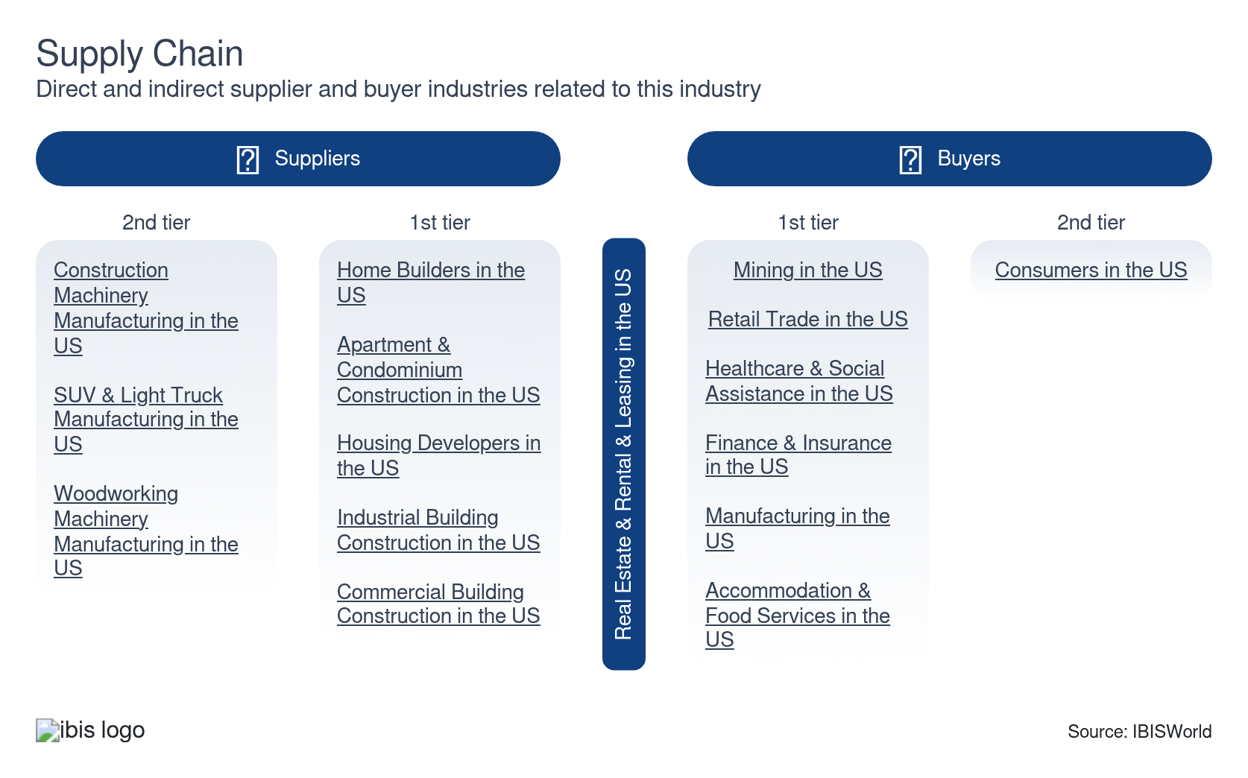

What power do buyers and suppliers have over the industry?

Buyers: Larger downstream buyers have more power
Moderate | Increasing
- There's a stark difference between large and small companies when it comes to rental and lease agreements. Large companies can drive harder bargains and wield greater power in negotiations, resulting in lower rates for a longer duration. Many downstream buyers in this industry are large mining, healthcare and finance companies.
- On the other hand, smaller companies tend to have less buying power in renting or leasing negotiations. For example, these renters generally have to take what they can get in rent, while larger companies can push for more favorable rent prices.

Suppliers: Home builders and manufacturers hold moderate power
Moderate | Steady
- Suppliers like home builders and heavy equipment manufacturers wield moderate to strong bargaining power over the real estate and rental and leasing sector. Home builders influence housing supply and pricing, particularly in competitive markets where construction delays or material shortages can exacerbate inventory constraints. Heavy equipment manufacturers (e.g., Caterpillar, Komatsu) hold leverage because of high upfront costs, specialized machinery needs and limited alternatives, forcing rental providers to accept pricing or terms dictated by suppliers.
- The sector’s reliance on technologically advanced, eco-friendly equipment strengthens manufacturers’ position, as rental companies prioritize modern fleets to meet sustainability demands and client expectations. Supply chain disruptions and inflationary pressures amplify supplier power by restricting equipment availability and driving up operational costs for rental providers. While rental providers benefit from diverse fleet offerings, manufacturers’ control over production and innovation limits buyer flexibility, particularly in niche markets.

How do successful businesses manage buyer & supplier power?
Alter goods and services produced in favor of market conditions
In a renter's market (low demand, high vacancy), companies may offer additional services (cleaning, move-in specials) to attract tenants. This gives renters more bargaining power for better deals.
Develop a symbiotic relationship with another industry
Partnering with an industry that offers services attractive to tenants creates a bundled package. This could be co-working spaces with on-site tech support (tech industry) or apartments with grocery delivery options (retail sector).

7. Companies
https://my.ibisworld.com/us/en/industry/53/companies

Key Takeaways
- The real estate market operates at the local level. People buy and sell houses in specific neighborhoods and towns, creating numerous smaller markets rather than one national market dominated by a few giants.

Market Share
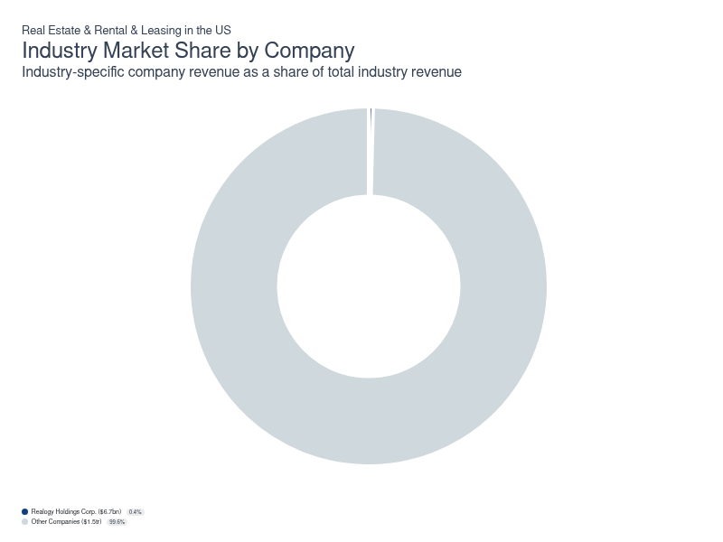
Chart displays current year only in the PDF version of this report. You can view and download chart for all other years associated with this industry on my.ibisworld.com.

Companies
Company | Market Share (%)  2026 | Revenue ($m)  2026 | Profit ($m)  2026 | Profit Margin (%)  2026
Realogy Holdings Corp. | 0.4 | 6,678.0 | 656.9 | 9.8

Realogy Holdings Corp.
Realogy Holdings Corp.
Company Details
Company Details
Industry Specific Revenue (2026) | $6.7bn
Industry Profit (2026) | $656.9m
Company Employees (2026) | 7,965
Market Share (2026) | 0.4%

Description
Description
Realogy Holdings is a public company headquartered in New Jersey with an estimated 7,965 employees. In the US, the company has a notable market share in at least one industry: Real Estate & Rental & Leasing, where they account for an estimated 0.4% of total industry revenue.

Brands and Trading Names
Brands and Trading Names
- Better Homes and Gardens
- Century 21
- Coldwell Banker
- Corcoran
- ERA
- Sotheby's

Company’s Industry Revenue, Market Share, and Profit Margin Over Time
Company’s Industry Revenue, Market Share, and Profit Margin Over Time
Year | Industry Revenue ($ million) | Market Share (%) | Profit Margin (%)
2008 | 4079 | 0.6 | 12.6
2009 | 3515 | 0.5 | 12.6
2010 | 4037 | 0.6 | 12.6
2011 | 4223 | 0.6 | 12.6
2012 | 4505 | 0.6 | 12.6
2013 | 4791 | 0.6 | 12.6
2014 | 5119 | 0.6 | 12.6
2015 | 5435 | 0.6 | 12.6
2016 | 5683 | 0.6 | 12.6
2017 | 5997 | 0.6 | 11.9
2018 | 5961 | 0.6 | 10.8
2019 | 5870 | 0.6 | 10.1
2020 | 6221 | 0.6 | 11.7
2021 | 7983 | 0.7 | 11.3
2022 | 6908 | 0.5 | 6.5
2023 | 6804 | 0.5 | 9.9
2024 | 6678 | 0.5 | 9.8
2025 | 6678 | 0.5 | 9.8
2026 | 6678 | 0.4 | 9.8

You can view and download company details on my.ibisworld.com.

8. External Environment
https://my.ibisworld.com/us/en/industry/53/external-environment

Key Takeaways
- Rental vacancy rates directly impact the real estate market. Low rates mean landlords can raise the rent, while high rates can challenge the industry.
- Per capita disposable income determines consumer affordability. As people have more disposable income, they can afford rental spaces, which pushes up demand and creates promising opportunities for the industry.

External Drivers

What demographic and macroeconomic factors impact the industry?
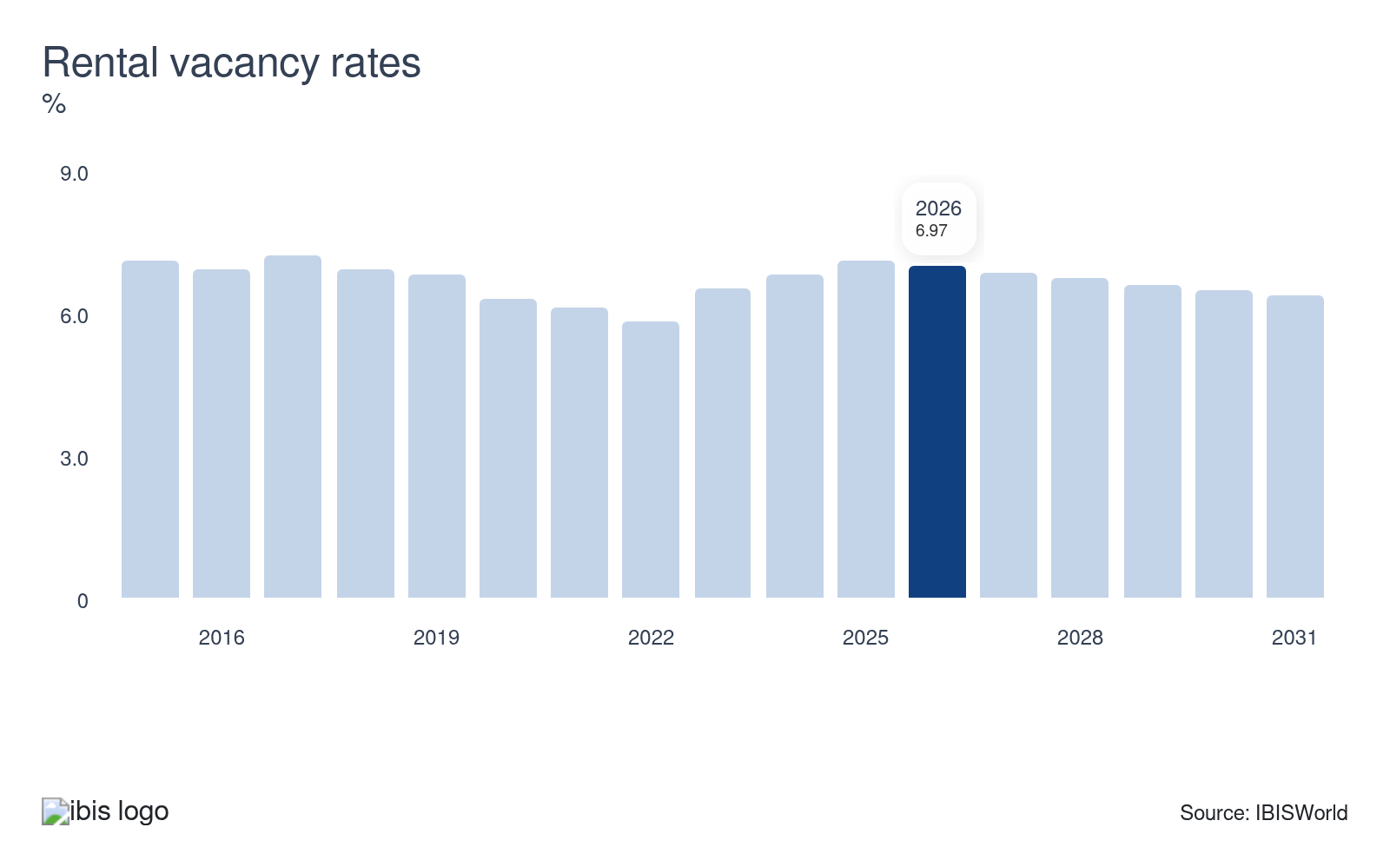
The rental vacancy rate can be used as a metric for the supply and demand of residential real estate available for rent. As vacancies drop, the supply of rental units becomes tight, allowing landlords to charge higher rents and boosting sector revenue. A gain in the rental vacancy rate poses a potential threat to the industry.
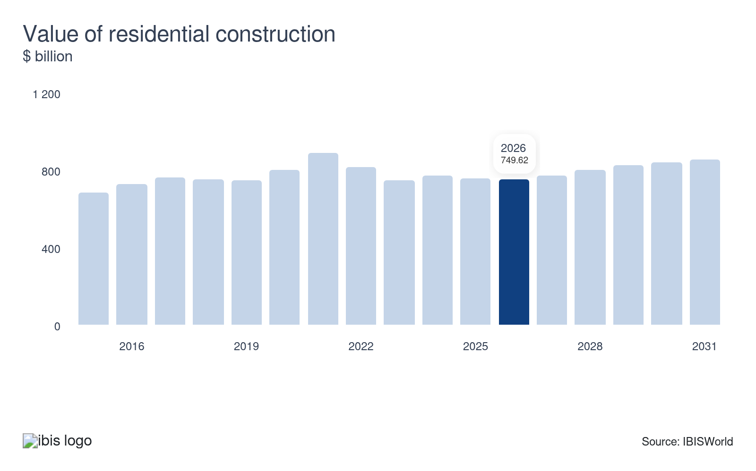
The value of residential construction represents the value of all new work performed, alterations, maintenance and repairs on residential structures in the US. As the value of residential construction climbs, it indicates rising demand for residential real estate, driving revenue gains for the sector. As construction activity gains, there will be renewed demand for construction equipment rentals, boosting sector revenue.
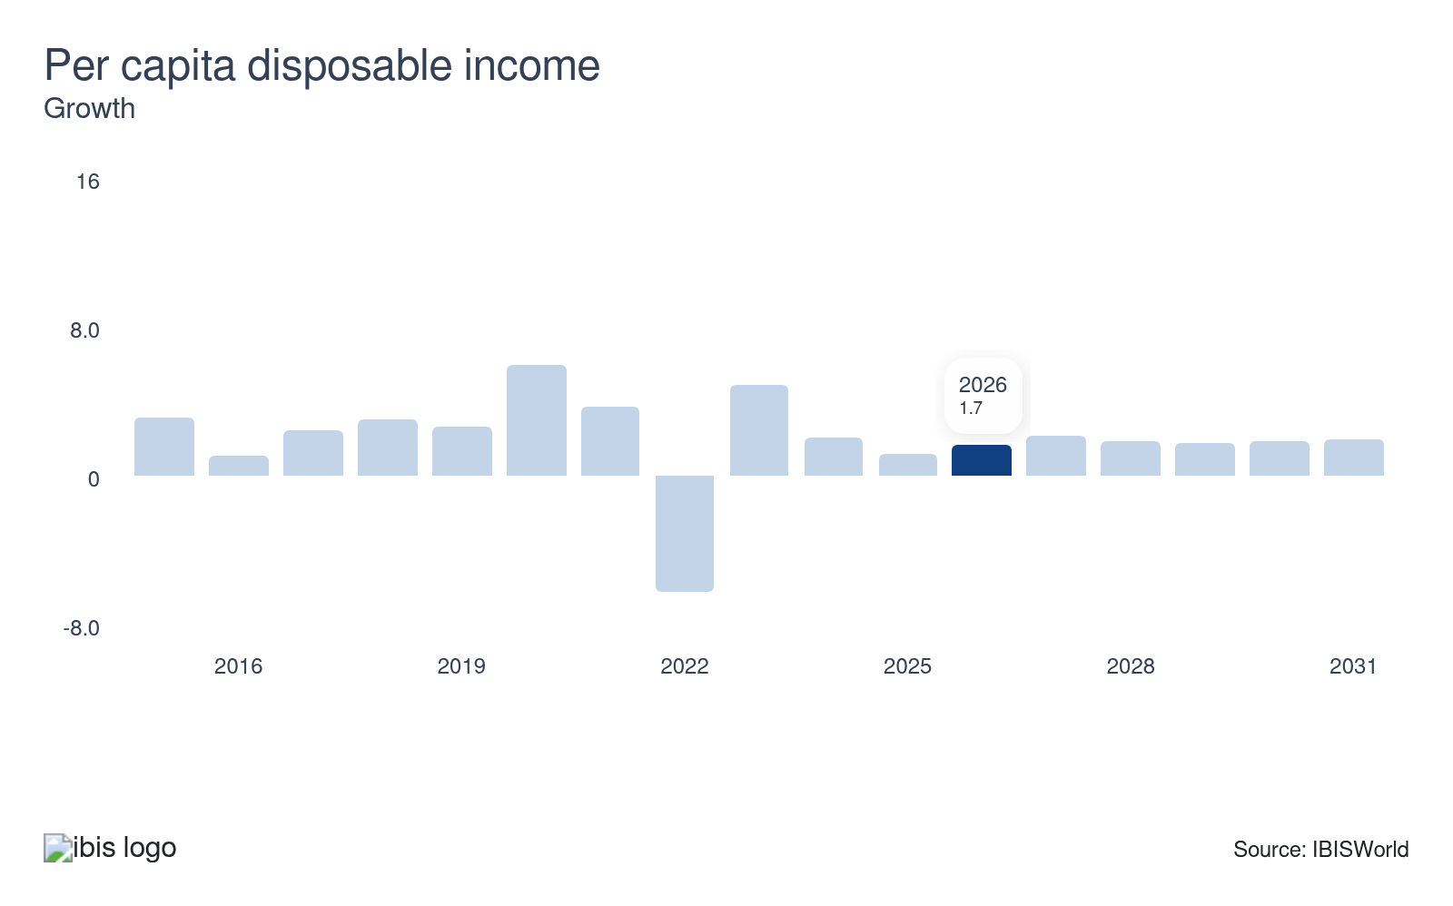
Per capita disposable income can be used as a metric of affordability. As per capita disposable income rises, consumers can better afford sector products, such as apartments and homes for rent, boosting sector demand. A climb in per capita income levels represents a substantial opportunity for the real estate and rental and leasing industry.
The homeownership rate demonstrates the share of consumers who own homes. When more people own homes, demand for rental properties decreases, leading to lower rental rates and potentially lower profit for landlords and leasing companies. Conversely, if homeownership rates drop, demand for rentals may gain, potentially driving up rental prices and profit.
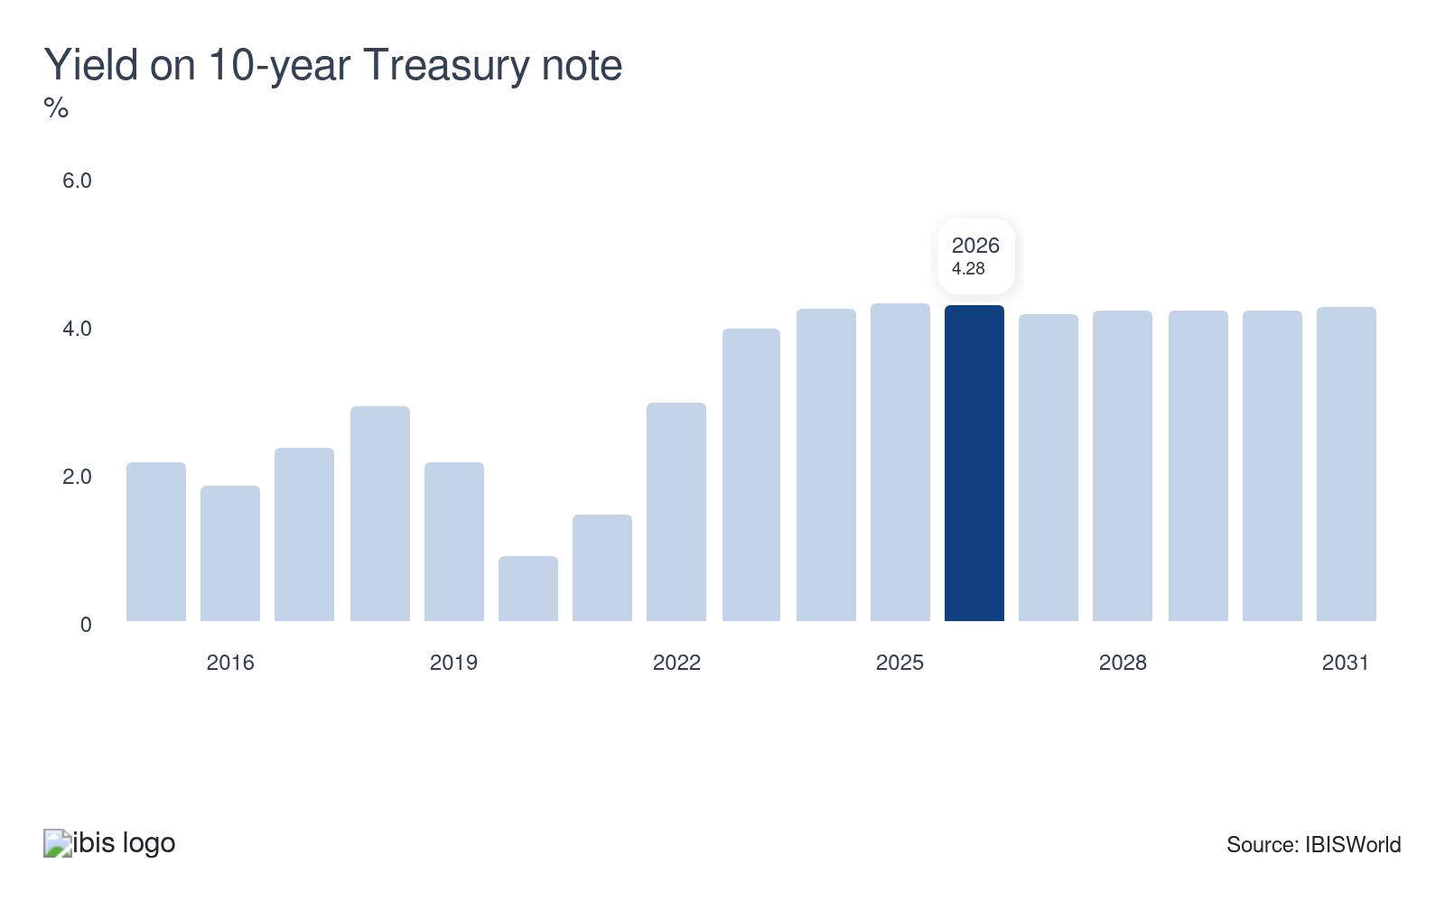
The yield on the 10-year Treasury note indicates the federal government's cost of borrowing. As yields gain, borrowing costs also climb. Interest rates on conventional mortgages and leases will align with the yield on the 10-year Treasury note. As interest rates climb, borrowing costs expand, pushing up sector revenue as long as cost increases do not stifle demand by pricing consumers out of the market.

Regulation & Policy
Moderate | Steady

What regulations impact the industry?

Building codes
Building codes fundamentally influence the real estate sector by enforcing safety, energy efficiency and accessibility standards, though they introduce complexities that fuel development costs and timelines. Jurisdictional variations in code interpretations and frequent regulatory updates create compliance challenges, often delaying projects and increasing expenses. While these standards enhance structural resilience and sustainability, they can inadvertently strain housing affordability, particularly in markets where strict requirements intersect with budget constraints. This dynamic underscores the ongoing tension between advancing safety mandates and maintaining cost-effective development practices.

Licensing requirements
Licensing requirements in the real estate sector enforce state-specific education, examination and ethical standards to regulate professionals. Agents must complete pre-licensing coursework, pass national and state exams and undergo background checks. Licenses are granted by state commissions, with reciprocity rules allowing limited cross-state practice under certain agreements. Brokerage firms often face additional registration requirements, including the appointment of a licensed principal broker to oversee operations. While the National Association of Realtors (NAR) does not issue licenses, it provides resources like the State Issues Tracker to help members navigate jurisdictional variations. These requirements ensure competency and ethical conduct but create fragmented compliance challenges because of differing state regulations.

The Fair Housing Act and the Real Estate Settlement Procedures Act
The Fair Housing Act (FHA) and Real Estate Settlement Procedures Act (RESPA) shape the real estate sector by enforcing equitable access and financial transparency. The FHA prohibits discrimination in housing transactions based on race, religion, sex, or national origin, requiring agents and brokers to adopt nondiscriminatory practices and address systemic biases, such as steering or unequal terms. RESPA mandates disclosure of settlement costs, prohibits kickbacks and regulates escrow accounts to prevent predatory lending, ensuring borrowers understand fees and loan terms. Together, these laws promote fair access to housing while standardizing transaction transparency, though compliance complexities persist, particularly in balancing disparate impact liability and evolving regulatory standards.

Environmental regulations
Environmental regulations significantly impact the equipment rental sector by accelerating the adoption of sustainable technologies, such as battery-, solar- and hybrid-powered equipment. Rental companies are investing in eco-friendly fleets (e.g., low-emission machinery and energy-efficient site accommodations) and renewable energy infrastructure (solar PV and battery systems) to align with mandates and customer demand for greener solutions. These regulations also spur digital transformation, with IoT and telematics optimizing fleet efficiency and reducing operational carbon footprints. While compliance increases upfront costs, it fosters long-term competitiveness by driving innovation and aligning with global sustainability goals. In 2024–2025, MSHA’s new silica rule and the EPA’s updated diesel exhaust fluid guidance and nonroad diesel emissions framework directly impact how rental fleets spec, operate and maintain heavy equipment.

Health and safety liability
OSHA regulations significantly influence the equipment rental sector by mandating safety standards for machinery maintenance, operator training and worksite compliance. Rental companies must ensure equipment meets structural integrity requirements (e.g., brakes, hydraulics) and provide safety documentation, including maintenance logs and compliance records. Recent changes include the January 2025 PPE fit mandate, requiring construction employers to supply properly sized protective gear for workers, which may extend to rental companies providing operator-ready equipment. Expanded injury reporting (effective 2024) and heat illness prevention protocols strengthen administrative burdens, while stricter violation penalties incentivize proactive compliance.

Assistance
Low | Steady

What assistance is available to this industry?

Public support doesn't apply to the industry
The Real Estate and Rental and Leasing sector doesn't receive any public sector support.

National Association of Realtors (NAR)
The National Association of Realtors (NAR) supports the real estate sector through grants, policy advocacy and operational frameworks that enhance market efficiency and professionalism. It funds consumer advocacy, fair housing initiatives and smart-growth programs to promote equitable access and community revitalization. NAR also provides legal action support and independent contractor protections, safeguarding agents’ flexibility while ensuring ethical standards. By maintaining the Clear Cooperation Policy (CCP), NAR reinforces MLS transparency, requiring brokers to share listings publicly within one business day to ensure fair buyer access and seller exposure. NAR advocates for first-time homebuyer savings accounts and brownfield redevelopment incentives to address affordability and sustainable development.

The American Rental Association
The American Rental Association (ARA) is a sizable trade association that researches the equipment rental industry. It allows communication between manufacturers, distributors and rental centers. The ARA primarily assists companies through lobbying and offers resources, events and seminars that equip businesses with appropriate knowledge and practices. The ARA provides market metrics and trend information. Rental and leasing professionals can leverage these resources to better understand the rental market dynamics.

9. Financial Benchmarks
https://my.ibisworld.com/us/en/industry/53/financial-benchmarks
Profit Margin  49.1 %  ↑ Higher than sector | Average Wage  $42,732  ↓ Lower than sector | Largest Cost  Depreciation  18.9% of Revenue

Key Takeaways
- Profit has improved as pricing power and capital-light models expand profit. High home prices, resilient rents and the growth of fee- and royalty-based businesses have lifted returns even as transaction volumes and some costs fluctuate.
- Depreciation remains a significant expense, especially for asset-heavy rental fleets. However, it has shrunk slightly as a share of revenue because top-line growth has outpaced the depreciation burden on buildings, vehicles and heavy equipment.

Cost Structure
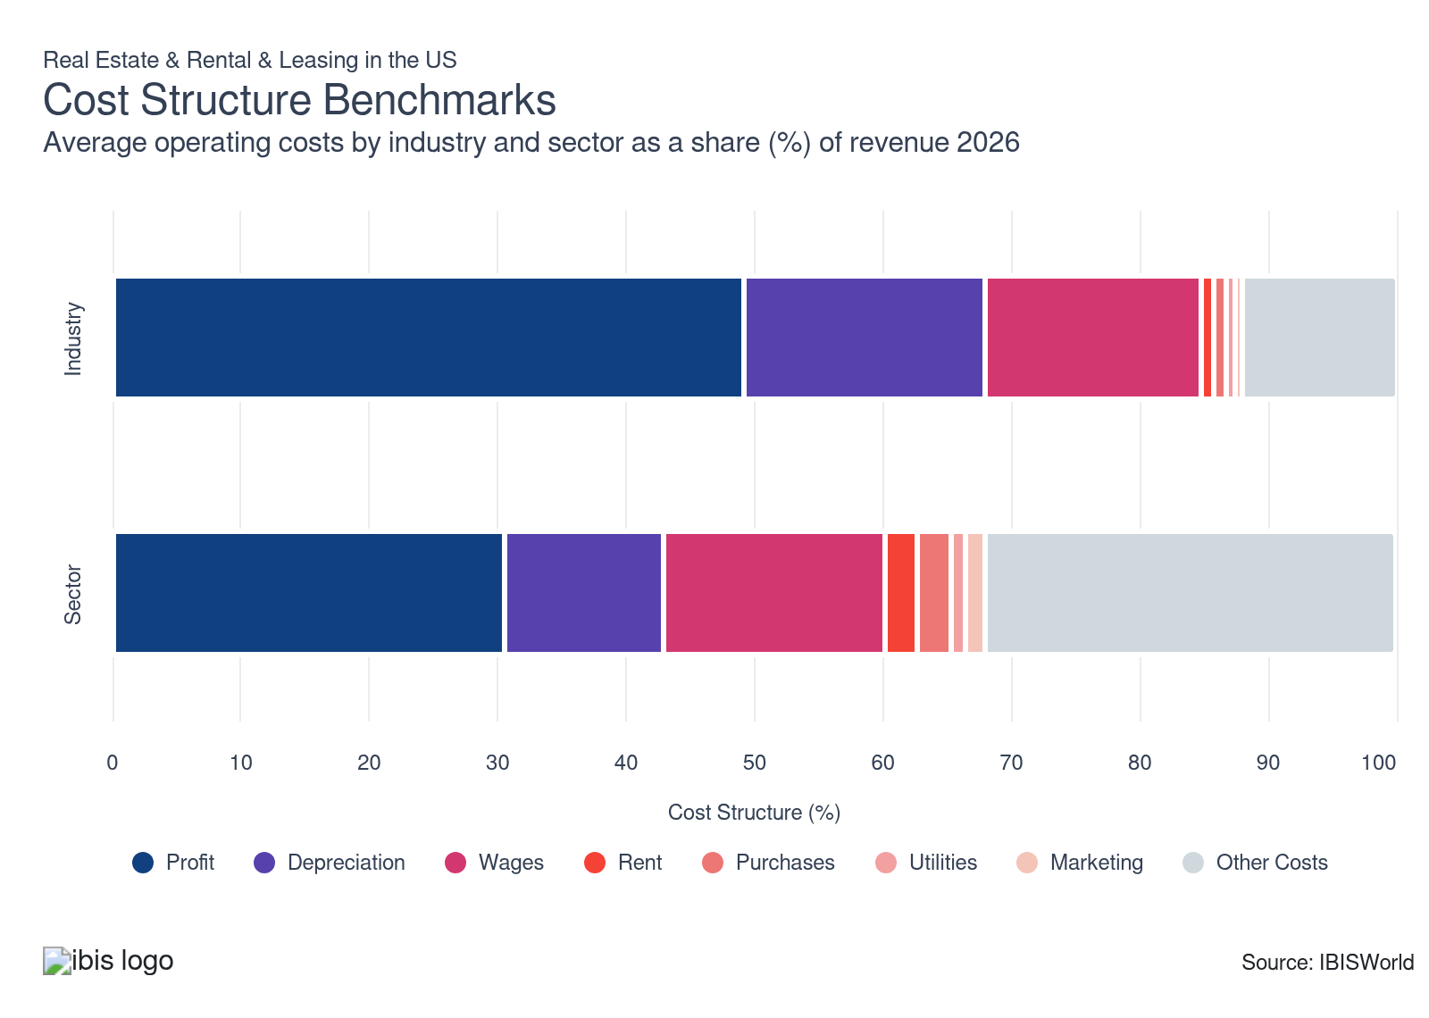
Chart displays current year only in the PDF version of this report. You can view and download chart for all other years associated with this industry on my.ibisworld.com.

What trends impact industry costs?

Rental demand and capital-light models power profit growth
- Profit in the sector primarily depends on pricing power, occupancy and utilization rates, capital and financing costs, operating efficiency and the mix of higher-margin segments, such as rentals and intangible licensing. High home prices and rents lift net operating income and fee revenue, while scale, technology and disciplined cost control help preserve profit even when transaction volumes soften.
- Industry profit has climbed since 2021 because asset values and rents rose faster than many input costs, widening the spread between revenue and expenses. Tight housing and industrial space supply, strong rental demand, and the shift toward capital-light, fee- and royalty-based models (equipment rental, auto leasing, software and brand licensing) have all supported higher profitability across the broader real estate and rental and leasing value chain.

Depreciation costs are relatively high
- Because of the nature of Real Estate and Rental and Leasing services, depreciation is one of the higher costs for businesses. The IRS assigns different depreciation schedules to various property types. Land itself is not depreciable as it's considered to have an indefinite lifespan. Depreciation deductions only apply to the building structure and any permanent improvements.
- Rental and leasing industries, particularly those dealing with heavy machinery and vehicles, often require significant initial investment. These assets depreciate over time, leading to high depreciation costs. Depreciation has slightly declined over the past five years because revenue has been growing faster than depreciation.

Wages significantly vary by subsector
- Wages in the Real Estate subsector are relatively low because of the prevalence of non-employing businesses that derive most of their income from their profit.
- Wages for companies in the Rental and Leasing subsector are skewed upward because there are fewer non-employing businesses. In addition, the presence of employers requires a wage structure.
- Wage costs have declined over the past five years as technology in real estate and rental transactions has reduced administrative costs. Technology often replaces jobs previously performed by humans, reducing demand for certain roles and lowering wages across the sector.

Rent prices have remained stable
- Since storefronts must be rented and maintained, companies in the rental and leasing subsegment tend to have higher rent costs. Many rental companies also maintain storage and warehouse space for their products. Rent is not a factor for Real Estate subsector businesses if they own their buildings.
- Rent costs have remained stable as a share of industry revenue over the past five years. Commercial leases are often long-term agreements, meaning rent prices are locked in for extended periods. This keeps rental costs stable for businesses.

Limited inputs reduce purchase costs
- Purchase costs are low on average because companies in the real estate subsector do little purchasing and require few inputs to operate. Purchases in this subsector typically include software or maintenance charges.
- Conversely, businesses in the Rental and Leasing subsector will incur higher purchase costs, typically closer to 15.0%, because of the need to stock an inventory of goods and equipment available for rent or lease.
- Inflation has elevated purchase costs over the past five years. However, revenue has kept pace with the gain in purchase costs, causing the purchase's share of revenue to remain steady.

Climbing electricity costs elevate utility costs
- Utility costs are higher in the Real Estate subsector because residential dwellings consume large amounts of power and water. This subsector pushes up the average sector utility costs because Rental and Leasing subsector companies typically pay half the sector average for rent and utilities.
- According to CBS News' price tracker, the cost of electricity has risen from $0.15 per kilowatt-hour in 2022 to $0.19 per kilowatt-hour in 2025.

Word-of-mouth referrals lessen marketing costs
- Marketing expenses are minimal for this sector because most companies rely on word-of-mouth referrals. Since most goods provided by the Rental and Leasing subsector are substitutable, a proven reputation for customer satisfaction and fair prices will prove more beneficial than an advertising campaign.
- Real estate is typically not advertised extensively, with residential landlords relying on word-of-mouth referrals. Marketing costs have remained stable over the past five years.

Business insurance costs have climbed since 2021
- Other operating expenses include communication charges, licensing fees, legal bills, insurance and other administration expenses. The majority of the industry's other costs stem from fringe benefits and legal expenses.
- Business insurance costs have increased because of more claims from natural disasters, cyber incidents and pandemic-related losses. Revenue growth has outpaced rising insurance costs, causing the other segment's share of industry revenue to dip over the past five years.
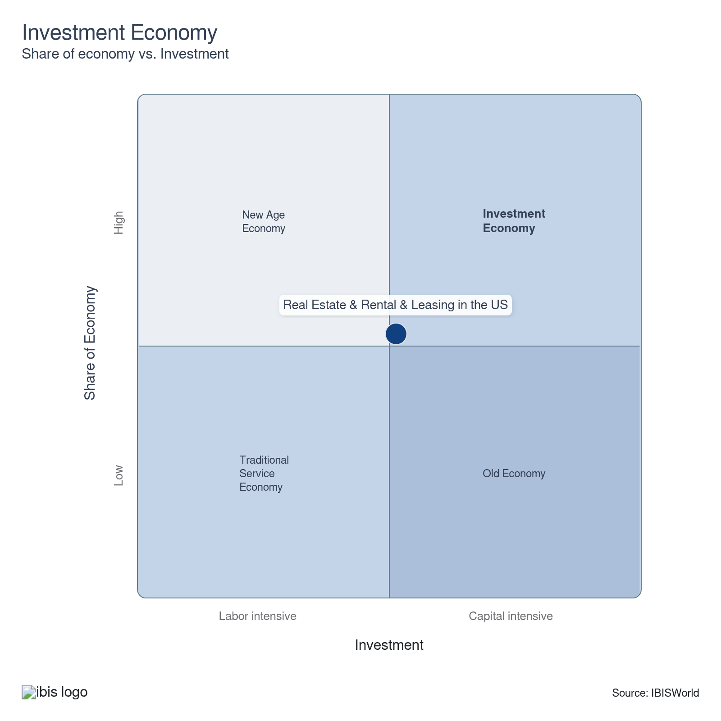

Key Ratios
Year | Revenue per Employee  ($) | Revenue per Enterprise  ($ Million) | Employees per Estab.  (Units) | Employees per Enterprise  (Units) | Average Wage  ($) | Wages/ Revenue  (%) | Estab. per Enterprise  (Units) | IVA/ Revenue  (%)
2006 | 222,140 | 0.4 | 1.7 | 1.7 | 41,238 | 18.6 | 1.0 | 83.2
2007 | 221,618 | 0.4 | 1.7 | 1.7 | 40,669 | 18.4 | 1.0 | 82.7
2008 | 221,665 | 0.4 | 1.7 | 1.8 | 40,658 | 18.3 | 1.0 | 82.7
2009 | 217,190 | 0.4 | 1.6 | 1.7 | 39,818 | 18.3 | 1.0 | 82.5
2010 | 215,986 | 0.4 | 1.6 | 1.6 | 40,642 | 18.8 | 1.0 | 83.9
2011 | 222,792 | 0.4 | 1.6 | 1.6 | 41,471 | 18.6 | 1.0 | 83.9
2012 | 229,721 | 0.4 | 1.6 | 1.6 | 42,383 | 18.4 | 1.0 | 84.5
2013 | 235,527 | 0.4 | 1.6 | 1.6 | 41,821 | 17.8 | 1.0 | 82.2
2014 | 239,705 | 0.4 | 1.6 | 1.6 | 42,492 | 17.7 | 1.0 | 83.9
2015 | 245,075 | 0.4 | 1.6 | 1.6 | 43,388 | 17.7 | 1.0 | 83.3
2016 | 249,472 | 0.4 | 1.6 | 1.6 | 43,440 | 17.4 | 1.0 | 83.2
2017 | 250,963 | 0.4 | 1.5 | 1.6 | 43,311 | 17.3 | 1.0 | 82.9
2018 | 250,978 | 0.4 | 1.5 | 1.6 | 43,317 | 17.3 | 1.0 | 83.5
2019 | 255,198 | 0.4 | 1.5 | 1.6 | 44,153 | 17.3 | 1.0 | 83.6
2020 | 245,791 | 0.4 | 1.5 | 1.6 | 43,847 | 17.8 | 1.0 | 83.0
2021 | 265,785 | 0.4 | 1.5 | 1.5 | 45,827 | 17.2 | 1.0 | 84.0
2022 | 258,012 | 0.4 | 1.5 | 1.6 | 44,724 | 17.3 | 1.0 | 83.8
2023 | 254,906 | 0.4 | 1.5 | 1.6 | 43,277 | 17.0 | 1.0 | 84.4
2024 | 256,753 | 0.4 | 1.6 | 1.6 | 42,802 | 16.7 | 1.0 | 85.0
2025 | 255,639 | 0.4 | 1.5 | 1.6 | 42,765 | 16.7 | 1.0 | 84.9
2026 | 254,691 | 0.4 | 1.5 | 1.6 | 42,732 | 16.8 | 1.0 | 84.8
2027 | 254,716 | 0.4 | 1.5 | 1.6 | 42,733 | 16.8 | 1.0 | 84.8
2028 | 254,984 | 0.4 | 1.5 | 1.6 | 42,742 | 16.8 | 1.0 | 84.9
2029 | 254,588 | 0.4 | 1.5 | 1.6 | 42,729 | 16.8 | 1.0 | 84.8
2030 | 254,369 | 0.4 | 1.5 | 1.6 | 42,721 | 16.8 | 1.0 | 84.8
2031 | 254,175 | 0.4 | 1.5 | 1.6 | 42,715 | 16.8 | 1.0 | 84.8
2032 | 254,245 | 0.4 | 1.5 | 1.6 | 42,717 | 16.8 | 1.0 | 84.8
*Figures are inflation adjusted to 2026
*Figures are inflation adjusted to 2026

10. Key Statistics
https://my.ibisworld.com/us/en/industry/53/key-statistics

Industry Data

Values
Year | Revenue  ($ Million) | IVA  ($ Million) | Estab.  (Units) | Enterprises  (Units) | Employment  (Units) | Wages  ($ Million)
2006 | 1,030,225.4 | 856,886.2 | 2,803,054 | 2,726,907 | 4,637,729 | 191,251.6
2007 | 1,008,636.7 | 833,848.8 | 2,707,195 | 2,628,125 | 4,551,232 | 185,095.8
2008 | 959,077.3 | 792,920.3 | 2,496,041 | 2,414,021 | 4,326,693 | 175,915.8
2009 | 957,693.7 | 790,088.4 | 2,723,926 | 2,642,663 | 4,409,469 | 175,576.9
2010 | 926,485.0 | 777,477.8 | 2,690,462 | 2,610,265 | 4,289,560 | 174,335.9
2011 | 949,854.8 | 797,064.0 | 2,687,449 | 2,608,752 | 4,263,406 | 176,808.7
2012 | 994,825.0 | 841,122.5 | 2,739,682 | 2,659,940 | 4,330,587 | 183,543.2
2013 | 1,041,121.8 | 855,346.0 | 2,805,815 | 2,724,779 | 4,420,387 | 184,863.4
2014 | 1,094,290.3 | 918,405.3 | 2,910,867 | 2,826,557 | 4,565,163 | 193,985.1
2015 | 1,152,148.0 | 959,785.1 | 3,013,382 | 2,927,152 | 4,701,207 | 203,975.9
2016 | 1,194,831.1 | 994,254.4 | 3,068,528 | 2,978,086 | 4,789,446 | 208,055.6
2017 | 1,237,942.4 | 1,025,734.8 | 3,191,321 | 3,094,122 | 4,932,759 | 213,644.6
2018 | 1,276,450.0 | 1,065,314.6 | 3,294,258 | 3,197,205 | 5,085,899 | 220,304.8
2019 | 1,322,533.4 | 1,105,656.5 | 3,367,506 | 3,270,016 | 5,182,391 | 228,816.9
2020 | 1,295,091.7 | 1,074,621.6 | 3,426,127 | 3,328,204 | 5,269,081 | 231,030.9
2021 | 1,396,723.6 | 1,173,448.8 | 3,530,708 | 3,431,658 | 5,255,084 | 240,824.4
2022 | 1,413,517.6 | 1,184,510.5 | 3,612,023 | 3,511,924 | 5,478,492 | 245,021.4
2023 | 1,417,891.5 | 1,197,047.9 | 3,640,093 | 3,545,754 | 5,562,417 | 240,722.5
2024 | 1,467,354.6 | 1,247,854.8 | 3,679,892 | 3,589,608 | 5,715,040 | 244,615.1
2025 | 1,478,103.0 | 1,255,542.3 | 3,736,134 | 3,646,695 | 5,781,993 | 247,267.3
2026 | 1,488,137.0 | 1,262,067.9 | 3,787,061 | 3,698,358 | 5,842,906 | 249,680.2
2027 | 1,514,199.9 | 1,284,647.2 | 3,852,083 | 3,762,077 | 5,944,667 | 254,033.6
2028 | 1,545,416.8 | 1,311,445.0 | 3,922,924 | 3,830,996 | 6,060,835 | 259,052.3
2029 | 1,566,520.1 | 1,328,636.0 | 3,980,065 | 3,887,293 | 6,153,168 | 262,917.0
2030 | 1,586,846.8 | 1,345,544.6 | 4,034,068 | 3,940,445 | 6,238,375 | 266,512.0
2031 | 1,608,224.1 | 1,363,380.4 | 4,091,609 | 3,997,016 | 6,327,223 | 270,266.6
2032 | 1,633,552.2 | 1,384,971.5 | 4,154,866 | 4,058,818 | 6,425,111 | 274,462.9

*Figures are inflation adjusted to 2026

Annual Change
Year | Revenue  % | IVA  % | Estab.  % | Enterprises  % | Employment  % | Wages  %
2006 | N/A | N/A | N/A | N/A | N/A | N/A
2007 | -2.1 | -2.7 | -3.4 | -3.6 | -1.9 | -3.2
2008 | -4.9 | -4.9 | -7.8 | -8.1 | -4.9 | -5.0
2009 | -0.1 | -0.4 | 9.1 | 9.5 | 1.9 | -0.2
2010 | -3.3 | -1.6 | -1.2 | -1.2 | -2.7 | -0.7
2011 | 2.5 | 2.5 | -0.1 | -0.1 | -0.6 | 1.4
2012 | 4.7 | 5.5 | 1.9 | 2.0 | 1.6 | 3.8
2013 | 4.7 | 1.7 | 2.4 | 2.4 | 2.1 | 0.7
2014 | 5.1 | 7.4 | 3.7 | 3.7 | 3.3 | 4.9
2015 | 5.3 | 4.5 | 3.5 | 3.6 | 3.0 | 5.2
2016 | 3.7 | 3.6 | 1.8 | 1.7 | 1.9 | 2.0
2017 | 3.6 | 3.2 | 4.0 | 3.9 | 3.0 | 2.7
2018 | 3.1 | 3.9 | 3.2 | 3.3 | 3.1 | 3.1
2019 | 3.6 | 3.8 | 2.2 | 2.3 | 1.9 | 3.9
2020 | -2.1 | -2.8 | 1.7 | 1.8 | 1.7 | 1.0
2021 | 7.8 | 9.2 | 3.1 | 3.1 | -0.3 | 4.2
2022 | 1.2 | 0.9 | 2.3 | 2.3 | 4.3 | 1.7
2023 | 0.3 | 1.1 | 0.8 | 1.0 | 1.5 | -1.8
2024 | 3.5 | 4.2 | 1.1 | 1.2 | 2.7 | 1.6
2025 | 0.7 | 0.6 | 1.5 | 1.6 | 1.2 | 1.1
2026 | 0.7 | 0.5 | 1.4 | 1.4 | 1.1 | 1.0
2027 | 1.8 | 1.8 | 1.7 | 1.7 | 1.7 | 1.7
2028 | 2.1 | 2.1 | 1.8 | 1.8 | 2.0 | 2.0
2029 | 1.4 | 1.3 | 1.5 | 1.5 | 1.5 | 1.5
2030 | 1.3 | 1.3 | 1.4 | 1.4 | 1.4 | 1.4
2031 | 1.3 | 1.3 | 1.4 | 1.4 | 1.4 | 1.4
2032 | 1.6 | 1.6 | 1.5 | 1.5 | 1.5 | 1.6

*Figures are inflation adjusted to 2026

DISCLAIMER
This product has been supplied by IBISWorld Inc. (‘IBISWorld’) solely for use by its authorized licenses strictly in accordance with their license agreements with IBISWorld. IBISWorld makes no representation to any other person with regard to the completeness or accuracy of the data or information contained herein, and it accepts no responsibility and disclaims all liability (save for liability which cannot be lawfully disclaimed) for loss or damage whatsoever suffered or incurred by any other person resulting from the use of, or reliance upon, the data or information contained herein. Copyright in this publication is owned by IBISWorld Inc. The publication is sold on the basis that the purchaser agrees not to copy the material contained within it for other than the purchasers own purposes. In the event that the purchaser uses or quotes from the material in this publication – in papers, reports, or opinions prepared for any other person – it is agreed that it will be sourced to: IBISWorld Inc.

